**APPRAISAL REPORT**

**CLIENT** Woodsboro Bank

**PROPERTY ADDRESS** 16424 Old Frederick Road

Emmitsburg, Maryland 21727

**REPORT DATE** September 4, 2024

**PRG REFERENCE NUMBER** 2011-21072-FLEX

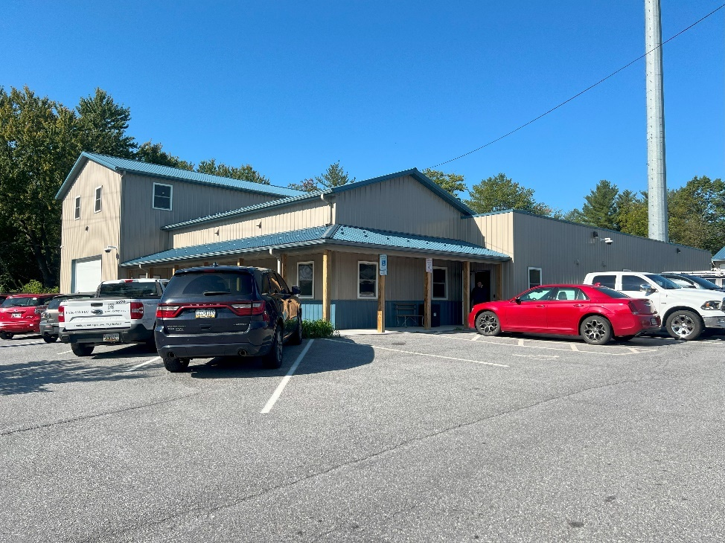

***16424 Old Frederick Road, Emmitsburg, Maryland***



**APPRAISAL REPORT**

**ADDRESS**

16424 Old Frederick Road

Emmitsburg, Maryland 21727

**LEGAL DESCRIPTION**

Tax Account: 05-173124

Liber 6217/Folio 1

Map 8/Grid 17/Parcel 149/Neighborhood 30000.11

4.46 Acres

Old Route 15

Frederick County, Maryland

Census Tract Number: 23224-24-021-7668.00

**AS OF**

September 10, 2024

*“As-Is” or Current Market Value*

**FOR**

Mr. Charles Reeder

Vice President

Woodsboro Bank

8 East Second Street

Suite 203

Frederick, Maryland 21701

**PREPARED BY**

Michael P. Pugh, MAI

John S. Molesworth

**Copyright © 2021**

**Pugh Real Estate Group, LLC**

**Real Estate Appraisers**

**P.O. Box 378**

**Frederick, Maryland 21705**

Pugh Real Estate Group, LLC

real estate appraisers

post office box 378

frederick, maryland 21705

(301) 898-1178

August 20, 2021

Mr. Charles Reeder

Vice President

Woodsboro Bank

8 East Second Street

Suite 203

Frederick, Maryland 21701

Re: 16424 Old Frederick Road

Emmitsburg, Maryland 21727

Dear Mr. Reeder:

In an engagement letter, dated September 9, 2024, you asked me to provide you with a current market value for the property identified above. This appraisal report provides an opinion of value as of September 10, 2024, which was the date of inspection. A leased fee valuation isn’t appropriate since the entire building and site is owner occupied. The attached appraisal report provides essential data and detailed reasoning employed in reaching my opinion of value.

**SUMMARY OF SITE, ZONING, AND IMPROVEMENTS**

The subject property consists of one parcel (149) that has a total of 4.46 acres or 194,278 square feet of land that is located on Old Frederick Road in an un-incorporated area of Frederick County near the town of Emmitsburg.

At the time of the property inspection, the subject property is improved with two buildings – both used by Holtzople Heating and Air Conditioning service. The first building (“main building”) was originally constructed as an automobile gas/service building in the 1960s and was renovated/expanded in 2014. This building includes 9,310 square feet of gross building area. The second building is a warehouse that was constructed in 2017. This building includes 4,000 square feet of gross building area.

The subject property is zoned General Industrial (G‑I). The General Industrial District is intended to provide areas of industries involving manufacturing or processing and for those industrial uses which cannot meet the performance criteria of the Limited Industrial (L‑I) District.

At the time of this appraisal, the subject property is not offered for sale and has not transferred within the three years preceding the date of this appraisal report.

**EXTRAORDINARY ASSUMPTIONS**

Uniform Standard of Professional Appraisal Practice (USPAP) defines an Extraordinary Assumption as, “an assumption, directly related to a specific assignment, as of the effective date of the assignment result, which, if found to be false, could alter the appraiser’s opinions or conclusions.”

*No extraordinary assumptions were considered for this appraisal.*

**HYPOTHETICAL CONDITIONS**

USPAP defines a Hypothetical Condition as, “that which is contrary to what is known the appraiser to exist on the effective date of the assignment results but is used for the purpose of analysis.”

*No hypothetical conditions were used for this appraisal.*

At the time of this appraisal, the subject property is not currently listed for sale. After careful consideration of all the factors which create value, it is my opinion that the subject property has a value as follows:

|  |  |  |  |
| --- | --- | --- | --- |
| **VALUE TYPE** | **INTEREST APPRAISED** | **DATE OF VALUE** | **VALUE** |
| Current market Value | Fee Simple | September 10, 2024 | $1,750,000 |

If you have any questions concerning this appraisal or the value conclusions developed in this report, please do not hesitate to contact me.

Sincerely,

|  |  |
| --- | --- |
| mike sign  **Michael P. Pugh, MAI**  **Certified General Real Estate Appraiser**  **State of Maryland – License No. 04-29481** |   **John S. Molesworth**  **Real Estate Appraiser Trainee**  **State of Maryland – License No. 0635415** |

|  |  |
| --- | --- |
| **TABLE OF CONTENTS** | **Page** |
| SUMMARY OF IMPORTANT FACTS AND CONCLUSIONS | 5 |
| CERTIFICATE OF APPRAISAL | 6 |
| SCOPE OF THE APPRAISAL | 7 |
| ASSUMPTIONS AND LIMITING CONDITIONS | 8 |
| KEY TERMS FOR THIS APPRAISAL REPORT | 10 |
| IDENTIFICATION OF THE PROPERTY | 12 |
| SUBJECT PROPERTY HISTORY | 14 |
| REGIONAL DATA | 15 |
| NEIGHBORHOOD DATA | 25 |
| REAL ESTATE TAX ANALYSIS | 29 |
| MARKET ANALYSIS | 31 |
| ZONING | 38 |
| SITE DATA | 40 |
| DESCRIPTION OF THE IMPROVEMENTS | 47 |
| HIGHEST AND BEST USE | 57 |
| VALUATION METHODOLOGY | 61 |
| SITE VALUATION | 62 |
| COST APPROACH | 63 |
| INCOME APPROACH | 66 |
| SALES COMPARISON APPROACH | 75 |
| RECONCILIATION OF VALUE INDICATIONS | 84 |

**ADDENDUM:**

APPRAISER QUALIFICATIONS

ENGAGEMENT LETTER

|  |  |
| --- | --- |
| **SUMMARY OF IMPORTANT FACTS AND CONCLUSIONS** | |
| **Address** | 16424 Old Frederick Road  Emmitsburg, Maryland 21727  Tax Account Number: 05-173124 |
| **Date of Value Estimate** | September 10, 2024 “As-is” or “current market value" |
| **Date of Appraisal Report** | August 20, 2021 |
| **Property Rights Appraised** | Fee Simple |
| **Land Area** | 4.46 Acres or 194,278 Square Feet. |
| **Improvements** | At the time of the property inspection, the subject property is improved with two buildings. The first building (“main building”) was originally constructed as an automobile gas/service building in the 1960s and was renovated/ expanded in 2014 and includes 9,310 square feet of gross building area. The second building is a warehouse that was constructed in 2017 and includes 4,000 square feet of gross building area. Both buildings have a combined gross building area of 13,130 square feet. |
| **Zoning** | The subject property is zoned GI (General Industrial) by Frederick County Planning Department. |
| **Intended Use** | To assist the client in a decision concerning a proposed federal related, real estate financing transaction. |
| **Client/Intended User** | The client and intended users include representatives of the Woodsboro Bank and its’ duly appointed committees. |
| **HIGHEST AND BEST USE** | |
| **As Vacant** | Warehouse/office building. |
| **As Improved** | Continue use as improved. |
| **VALUATION** | |
| Current Market Value as September 10, 2024 | Site Valuation Abandoned  Cost Approach Abandoned  Sales Comparison Approach $1,730,000  Income Capitalization Approach $1,765,000  **Conclusion:**  **$1,750,000** |

**CERTIFICATE OF APPRAISAL**

I certify that, to the best of my knowledge and belief:

1. The statements of fact contained in this report are true and correct.
2. The reported analyses, opinions, and conclusions are limited only by the reported assumptions and limiting conditions and are my personal, impartial, and unbiased professional analyses, opinions, and conclusions.
3. I have no present or prospective interest in the property that is the subject of this report and no personal interest with respect to the parties involved.
4. I have not appraised this property within the last three years.
5. I have no bias with respect to the property that is the subject of this report or to the parties involved with this assignment.
6. My engagement in this assignment was not contingent upon developing or reporting predetermined results.
7. My compensation for completing this assignment is not contingent upon the development or reporting of a predetermined value or direction in value that favors the cause of the client, the amount of the value opinion, the attainment of a stipulated result, or the occurrence of a subsequent event directly related to the intended use of this appraisal.
8. My analyses, opinions, and conclusions were developed, and this report has been prepared, in conformity with the Uniform Standards of Professional Appraisal Practice.
9. I have made a personal inspection of the property that is the subject of this report.
10. No one provided significant real property appraisal assistance to the person signing this certification.
11. The reported analyses, opinions, and conclusions were developed, and this report has been prepared, in conformity with the Code of Professional Ethics and Standards of Professional Appraisal Practice of the Appraisal Institute.
12. The use of this report is subject to the requirements of the Appraisal Institute relating to review by its duly authorized representatives.
13. As of the date of this report, I have completed the Standards and Ethics Education Requirement of the Appraisal Institute for Designated Members.

|  |  |
| --- | --- |
| mike sign  **Michael P. Pugh, MAI**  **Certified General Real Estate Appraiser**  **State of Maryland – License No. 04-29481** |   **John S. Molesworth**  **Real Estate Appraiser Trainee**  **State of Maryland – License No. 06-35415** |

|  |  |
| --- | --- |
| **SCOPE OF THE APPRAISAL** | |
| Real estate is valued based using the following techniques – Site Valuation, Cost, Income and Sales Comparison Approaches – which are defined below: | |
| **SITE VALUATION** | This approach to value is the estimation of value of a subject site, as vacant and ready to be improved, based upon factual data extracted from sales of similar or reasonably similar properties. |
| **COST** | This approach to value is utilized to reflect the value of the property by adding together the estimated value of the land, as vacant, and the reproduction cost new of the improvements, less the accrued depreciation. |
| **INCOME CAPITALIZATION APPROACH** | This approach estimates value by the capitalization of the net income stream. |
| **SALES COMPARISON APPROACH** | This approach to value is the estimation of value of a subject property based upon factual data extracted from sales of similar or reasonably similar properties. |
| These data will be gathered from the subject area and all pertinent data gathered will be presented, discussed, and considered. Confirmation of data will be made as needed to assure an understanding of the actions of the market. | |
| The appraiser has performed the following in arriving at a final value estimate for the subject property under market value “as-is.”   * Michael P. Pugh and John S. Molesworth personally inspected the subject property on September 10, 2024 with the owner present. The scope of this inspection included the interior and exterior of the buildings, site, and surrounding area. * Gathered and analyzed data on comparable improved sales in the market area from the Maryland Department of Assessment and Taxation, and MRIS; * Spoke with realtors engaged in the marketplace within the subject area as to the sale, leasing, and marketing times for similar type properties; * Reviewed data of similar property sales in both MRIS and CoStar to verify the competitive environment of properties that are offered for sale that have similar characteristics as the subject property; * Reviewed material available from the Frederick County Planning Zoning Department regarding the subject property zoning and surrounding area; * Reported results using USPAP prescribed content for a summary appraisal report; * It is important to note that the opinion of value provided in this report is based on the assumption that the property is not negatively affected by the existence of hazardous substances or other environmental conditions. * Real Estate Appraisers are not experts in the identification of hazardous substances or other environmental conditions. During the property inspection and inquiries of the subject site, the appraisers did not become aware of any information that would lead to the conclusion that any negative environmental conditions exist on the subject property. * There are no non-realty sources of income such as business income, income attributable to intangibles, and priced premiums associated with non-market or subsidized financing in accordance with the proper identification of the property rights appraised. | | |

**ASSUMPTIONS & LIMITING CONDITIONS**

* Unless otherwise stated, the value appearing in this appraisal represents the opinion of the Market Value or the Value Defined as of the date specified. Market Value of real estate is affect­ed by national and local economic conditions and, consequently, will vary with future changes in such conditions.
* The value estimated in this appraisal report is gross, without consideration given to any encumbrance, restriction or question of title, unless specifically defined.
* The value is reported in dollars on the basis of the currency prevailing at the date of appraisal.
* This appraisal report covers only the property described and any values or rates utilized are not to be construed as applicable to any other property, however similar the properties might be.
* It is assumed that the title to the premises is good, that the legal description is correct, that the improvements are entirely and correctly located on the property described, and that there are no encroachments on this property. However, no investigation or survey has been made.
* This appraisal expresses my opinion, and the employment to make this appraisal was in no way contingent upon the reporting or predetermined value or conclusion.
* No responsibility is assumed for matters legal in nature, nor is any opinion of title rendered. In the performance of my inves­tigation and analysis leading to the conclusions reached herein, the statements of others were relied on.
* Neither all nor any part of the contents of this report (espe­cially any conclusions, the identity of the appraiser or the firm with which he is connected, or any reference to the Appraisal Institute or any of its designations) shall be disseminated to the public through advertising media, public relations media, news media, sales media or any other public means of communica­tion without my prior written consent and approval.
* It is assumed that there are no hidden or unapparent conditions of the property, subsoil, or structures which would render it more or less valuable. The Appraiser assumes no responsibility for such conditions or the engineering which might be required to discover these factors.
* Unless otherwise stated in this report, the existence of hazard­ous substances, including without limitation asbestos, polychlor­inated biphenyls, petroleum leakage, or agricultural chemicals, which may or may not be present on the property, or other envi­ronmental conditions, were not called to the attention of the appraiser, nor did the appraiser become aware of such during the appraiser's inspection. The appraiser has no knowledge of the existence of such materials on or in the property unless other­wise stated. The appraiser, however, is not qualified to test for such substances or conditions. If the presence of such substances, such as asbestos, formaldehyde foam insulation, or other hazardous substances or environmental conditions, may affect the value of the property, the value estimated is predi­cated on the assumption that there is no such proximity thereto that would cause a loss in value. No responsibility is assumed for any such conditions, nor for any expertise or engineering knowledge required to discover them.
* All mortgages, liens, encumbrances, leases, and servitudes have been disregarded unless so specified within the report. The property is appraised as though under responsible ownership and competent management.
* It is assumed that there is full compliance with all applicable federal, state and local environmental regulations and laws unless non‑compliance is stated, defined and considered in the appraisal report.
* It is assumed that all required licenses, consents or other legislative or administrative authority from any local, state or national government or private entity or organization have been or can be obtained or renewed for any use on which the value estimate contained in this report is based. It is assumed that a permit for the construction of the entire entity is in place.
* It is assumed that the subject property and the market data used within this report does not have a level of Radon in excess of the limits established by the Environmental Protection Agency (EPA).
* The appraiser will not be required to give testimony or appear in court because of having made this appraisal unless previous arrangements are made with the appraiser prior to the writing of the report.
* Assumed that live and dead loads within the structure do not exceed the design feature of the building.
* Assumed that the soils on the subject site will support the building improvements currently located on the site.
* Assumed that subject property owners have all appropriate permits and licenses required to operate the existing business. In addition, I assume that the subject property owners have the requisite management expertise for the continued operation of their business.
* Pertaining to the Americans with Disabilities Act (ADA), we have not made a specific compliance survey and analysis of this property to determine whether or not it is in conformity with the various detailed requirements of the ADA. It is possible that a compliance survey of the property together with a detailed analysis of the requirements of the ADA could reveal that the property is not in compliance with one or more of the requirements of the act. If so, this fact could have a negative effect upon the value of the property. Since we have no direct evidence relating to this issue, we did not consider possible noncompliance with the requirements of ADA in estimating the value of the property.
* The scope of this appraisal does not include personal property.
* This appraisal report was completed without the benefit of a title report.  It is assumed that the title to the premises is good, that the legal description is correct, that the improvements are entirely and correctly located on the property described, and that there are no encroachments on this property other than what is noted in the report.
* The property tax map and information from Frederick County land records were used as reference to determine/verify the site size and dimensions and it was assumed to be an accurate representation of the subject site.  A formal survey was not completed as part of this assignment.

|  |  |
| --- | --- |
| **KEY TERMS FOR THIS APPRAISAL ASSIGNMENT** | |
| **APPRAISAL REPORT** | The content of an Appraisal Report must be consistent with the intended use of the appraisal and, at a minimum: (i) state the identity of the client and any intended users, by name or type; (ii) state the intended use of the appraisal; (iii) summarize information sufficient to identify the real estate involved in the appraisal, including the physical, legal, and economic property characteristics relevant to the assignment; (iv) state the real property interest appraised; (v) state the type and definition of value and cite the source of the definition; (vi) state the effective date of the appraisal and the date of the report; (vii) summarize the scope of work used to develop the appraisal; (viii) summarize the information analyzed, the appraisal methods and techniques employed, and the reasoning that supports the analyses, opinions, and conclusions; exclusion of the sales comparison approach, cost approach, or income approach must be explained; (ix) state the use of the real estate existing as of the date of value and the use of the real estate reflected in the appraisal; (x) when an opinion of highest and best use was developed by the appraiser, summarize the support and rationale for that opinion; (xi) clearly and conspicuously:  state all extraordinary assumptions and hypothetical conditions; and state that their use might have affected the assignment results; and (xii) include a signed certification in accordance with Standards Rule 2-3. |
| **PURPOSE OF THE APPRAISAL** | The purpose of this appraisal assignment is to provide a supportable opinion of the market value of the Fee Simple interest in the subject property in its current “as is” condition. |
| **PROPERTY RIGHTS APPRAISED** | **Fee Simple.** *Absolute ownership unencumbered by any other interest or estate, subject only to the limitations of the four powers of government.[1]* |
| **DEFINITION OF MARKET VALUE** | The most probable price which a property should bring in a competitive and open market. Conditions requisite to a fair sale, the buyer and seller each acting prudently, knowledgeably, and assuming the price is not affected by undue stimulus. Implicit in this definition is the consummation of a sale whereby: 1) Buyer and seller are typically motivated; (2) Both parties are well informed or well advised, and acting in what they consider their own best interests; (3) A reasonable time is allowed for exposure in the open market; (4) Payment is made in terms of cash in U.S. dollars or in terms of financial arrangement comparable thereto; and, (5) The price represents the normal consideration for the property sold unaffected by special or creative financing or sales concessions granted by anyone associated with the sale.[2] |

|  |  |
| --- | --- |
| **EXPOSURE AND MARKETING TIME** | Exposure time as used in this appraisal report is defined as:  Exposure time. The estimated length of time the property interest being appraised would have been offered on the market prior to the hypothetical consummation of a sale at market value on the effective date of the appraisal; a retrospective estimate based on an analysis of past events assuming a competitive and open market.  Based upon the market data from the sales of comparable properties in the market my conclusion of exposure time follows:  Conclusion:  Exposure Time Eight to Ten Months  Marketing time. The time it takes an interest in real property to sell on the market subsequent to the date of appraisal.  Based upon the market data from the sales of comparable properties in the market my conclusion of exposure time follows:  Conclusion:  Marketing Time Eight to Ten Months |

|  |  |  |
| --- | --- | --- |
| **IDENTIFICATION OF THE SUBJECT PROPERTY** | | |
| **PROPERTY**  **ADDRESS** | 16424 Old Frederick Road  Emmitsburg, Maryland 21727 | | |
| **LEGAL**  **DESCRIPTION** | Tax Account: 05-173124  Liber 6217/Folio 1  Map 8/Grid 17/Parcel 149/Neighborhood 30000.11  4.46 Acres  Old Route 15  Frederick County, Maryland  Census Tract Number: 23224-24-021-7668.00 | | |
| **SUBJECT PROPERTY SUMMARY** | |  | | --- | | The subject property consists of one parcel (149) that has a total of 4.46 acres or 194,278 square feet of land that is located on Old Frederick Road in an un-incorporated area of Frederick County near the town of Emmitsburg.  At the time of the property inspection, the subject property is improved with two buildings – both used by Holtzople Heating and Air Conditioning service. The first building (“main building”) was originally constructed as an automobile gas/service building in the 1960s and was renovated/expanded in 2014. This building includes 9,310 square feet of gross building area. The second building is a warehouse that was constructed in 2017. This building includes 4,000 square feet of gross building area.  The subject property is zoned General Industrial (G‑I). The General Industrial District is intended to provide areas of industries involving manufacturing or processing and for those industrial uses which cannot meet the performance criteria of the Limited Industrial (L‑I) District.  At the time of this appraisal, the subject property is not offered for sale and has not transferred within the three years preceding the date of this appraisal report. | |  | | | |
| **SUBJECT PROPERTY TAX MAP** |  |
| **PHOTO – SUBJECT PROPERTY (MAIN BUILDING)** |  |
| **STORAGE BUILDING** |  |

**SUBJECT PROPERTY** **HISTORY**

The subject property is currently owned by Holtzople Real Estate Investments LLC (HREI, LLC). HREI, LLC acquired the property from Larry V. Holtzople on September 13, 2006 in a non-arms length transaction ($0) as recorded in Liber 6217/Folio 0001 of the Frederick County land records. Larry V. Holtzople originally acquired the subject property from C.F. Stouter Oil Company Inc. on November 8, 1983 for $180,000. This transaction was recorded in Liber 1218/Folio 299 in Frederick County's land records.

At the time of this appraisal, the subject property is not offered for sale and has not transferred within the three years preceding the date of this appraisal report.

**REGIONAL DATA – FREDERICK COUNTY**

**Summary & Location**

Frederick County is Maryland's largest county in size -- 663 square miles. The City of Frederick, the county seat, is intersected by five interstate and national highways that provide easy access to Baltimore (46 miles), Washington D.C. (44 miles), Gettysburg, PA (32 miles), Harpers Ferry, West Virginia (21 miles), and Leesburg, Virginia (25 miles). It is home to the 5,700-acre Catoctin Mountain Park, site of the Camp David Presidential Retreat. Frederick County is also Maryland's largest dairy producer and has the second largest concentration of biotech companies in the state, with over 80 biotech firms located within Frederick County. The following chart reflects driving distance from Frederick to key U.S. Cities:



**Regional View**



**Transportation & Linkages**

***Highways:*** Interstate 70, Interstate 270, U.S. Route 15, and U.S. Route 340.

***Mass Transit:*** MARC (commuter rail) service to Washington D.C. and Amtrak; public bus transportation throughout Frederick City and connecting other municipalities.

***Rail:*** CSX Transportation and Maryland Midland Railway (short line service).

***Truck:*** 76 local and long-distance trucking establishments are located in the county.

***Water:*** Served by the Port of Baltimore, 50' channel; a leading U.S. automobile and break-bulk port; seven public terminals including the state-of-the-art Intermodal Container Transfer Facility.

***Air:*** Served by Baltimore/Washington International Thurgood Marshall Airport (BWI); Reagan Washington National Airport; and Dulles International Airport. Frederick Municipal Airport offers jet and turboprop charter service and has two runways.

**Population**

Desirable living conditions have contributed to Frederick County being among the fastest growing counties in the region. From 2000 to 2010, Frederick County experienced a 19.2% increase in population while the State of Maryland's total population increased by 9% during the same time frame. According to U.S. Census, the 2020 population for Frederick County was 271,717, which is approximately 16.4% over the 2010 Census. The estimated population for 2022 was 287,079. Please note the following table (Source: U.S. Census):

|  |  |  |  |  |
| --- | --- | --- | --- | --- |
| **FREDERICK COUNTY: POPULATION PROFILE** | | | | |
|  | **2000** | **2010** | **2020** | **2022** |
| **Population** | **195,277** | **233,385** | **271,717** | **287,079** |

From 2010 to 2020, Frederick City experienced a 19.73% increase in population which is slightly higher than the rate noted for Frederick County. The census population in 2020 was 78,171. The estimated population for 2022 was 82,175. Please note the following table (Source: U.S. Census):

|  |  |  |  |  |
| --- | --- | --- | --- | --- |
| **FREDERICK CITY: POPULATION PROFILE** | | | | |
|  | **2000** | **2010** | **2020** | **2022** |
| **Population** | **52,767** | **65,289** | **78,171** | **82,175** |

Below is a chart showing the estimated population growth for the municipalities in Frederick County, from the 2010 U.S. Census to 2019:

|  |  |  |  |  |
| --- | --- | --- | --- | --- |
|  | **Population** | **Population** | **Estimated Growth** | **Estimated** |
| **City/Town** | **per 2010 Census** | **Per 2020 Census** | **Since 2010** | **Percent Increase** |
| **Brunswick** | 5,870 | 7,762 | 1,892 | 32.23% |
| **Burkittsville** | 151 | 151 | 0 | 0.00% |
| **Emmitsburg** | 2,814 | 3,156 | 342 | 0.00% |
| **Frederick** | 65,239 | 78,171 | 12,932 | 6.77% |
| **Middletown** | 4,136 | 4,943 | 807 | 6.71% |
| **Mt. Airy** | 9,288 | 9,654 | 366 | .93% |
| **Myersville** | 1,626 | 1,763 | 137 | 5.08% |
| **New Market** | 656 | 1,536 | 880 | 43.88% |
| **Rosemont** | 294 | 272 | 18 | 0.00% |
| **Thurmont** | 6,170 | 6,274 | 104 | 0.88% |
| **Walkersville** | 5,800 | 6,261 | 461 | 1.81% |
| **Woodsboro** | 1,141 | 1,181 | 40 | 0.87% |
|  | |  |  |  |

**Income**

According to U.S. Census, Frederick County’s median household income in 2020 was $97,730 which was 15% greater than the state of Maryland’s average of $84,805. Maryland had the highest median household income of any state in the U.S. according to the 2020 Census. The estimated median household income in 2022 was $115,724. The following information, obtained from the City of Frederick’s Office of Economic Development website, reflects the income data for Frederick County:

|  |  |  |  |  |  |  |
| --- | --- | --- | --- | --- | --- | --- |
| **Households by Income** | **2000** | | **2010** | | **2020** | |
| **Number** | **%** | **Number** | **%** | **Number** | **%** |
| <$15,000 | 5,014 | 7.2 | 4,116 | 4.9 | 4,339 | 4.7 |
| $15,000-$24,999 | 5,519 | 7.9 | 4,765 | 5.6 | 3,080 | 3.3 |
| $25,000-$34,999 | 6,554 | 9.3 | 4,507 | 5.3 | 4,131 | 4.4 |
| $35,000-$49,999 | 11,063 | 15.8 | 9,294 | 11.0 | 8,508 | 9.2 |
| $50,000-$74,999 | 16,815 | 24.0 | 17,466 | 20.7 | 13,761 | 14.9 |
| $75,000-$99,999 | 11,846 | 16.9 | 16,809 | 19.9 | 13,309 | 14.4 |
| $100,000-$149,000 | 9,495 | 13.5 | 18,339 | 21.7 | 21,473 | 23.2 |
| $150,000-$199,999 | 2,253 | 3.2 | 5,791 | 6.9 | 13,775 | 14.9 |
| $200,000+ | 1,556 | 2.2 | 3,431 | 4.1 | 9,921 | 10.7 |
|  | | | | | | |
| Median HH Income | $60,256 | | $77,242 | | $97,730 | |
| Average HH Income | $69,955 | | $88,872 | | $117,009 | |

Median household income for Frederick County increased over 28% between 2000 and 2010. Estimates for 2020 showed a 27% increase in median household income since 2010.

The median household income for Frederick City for 2020 was $74,801 (esri community profile) The estimated median income for 2022 according to census data was $89,981. The following chart, obtained from the City of Frederick’s Office of Economic Development website, reflects the income data for Frederick City:

|  |  |  |  |  |  |  |
| --- | --- | --- | --- | --- | --- | --- |
| **Households by Income** | **2000** | | **2010** | | **2020** | |
| **Number** | **%** | **Number** | **%** | **Number** | **%** |
| <$15,000 | 2,156 | 10.3 | 1,826 | 7.2 | 1,902 | 6.5 |
| $15,000-$24,999 | 2,275 | 10.9 | 2,128 | 8.4 | 1,756 | 6.0 |
| $25,000-$34,999 | 2,646 | 12.7 | 1,948 | 7.7 | 1,610 | 5.5 |
| $35,000-$49,999 | 3,864 | 18.5 | 3,654 | 14.5 | 4,537 | 15.5 |
| $50,000-$74,999 | 4,861 | 23.3 | 5,757 | 22.8 | 4,859 | 16.6 |
| $75,000-$99,999 | 2,678 | 12.8 | 4,622 | 18.3 | 4,098 | 14 |
| $100,000-$149,000 | 1,779 | 8.5 | 3,782 | 15.0 | 5,445 | 18.6 |
| $150,000-$199,999 | 360 | 1.7 | 900 | 3.6 | 2,605 | 8.9 |
| $200,000+ | 270 | 1.3 | 627 | 2.5 | 2,459 | 8.4 |
|  | | | | | | |
| Median HH Income | $47,793 | | $61,794 | | $74,801 | |
| Average HH Income | $57,064 | | $72,842 | | $98,516 | |

Median household income for Frederick City increased more than 29% between 2000 and 2010. Estimates for 2020 show a 21% increase in median household income since 2010.

**Labor & Employment**

The labor market of Frederick County also includes portions of other surrounding counties within the State of Maryland, as well as Loudoun County, Virginia; Adams County, Pennsylvania; and Jefferson County, West Virginia.

The Maryland Department of Labor reported that Frederick County's 2020 average unemployment rate was up significantly from 2019 numbers, due in large part to the effects of the pandemic. The first and second quarter 2020 rates were negatively impacted significantly by the Covid-19 pandemic, reaching 9.8% as of end April 2020). At the end of 2019, the rate was 2.6% in December, compared to 5.0% in December 2020. The unemployment rate continued to decrease in 2021 to end the year at 3.4% in December 2021 (source: U.S. Bureau of Labor Statistics, St. Louis Federal Reserve). The unemployment rate by December 2022 was 2.80%.

The workforce includes the population of Frederick County between the ages (living in Frederick County, not necessarily working in Frederick County) of 18 and 65.

|  |  |  |  |  |
| --- | --- | --- | --- | --- |
| Frederick County Labor Force Estimates | | | | |
|  | | | | |
| **YEAR** | **Labor Force** | **Employment** | **Unemployment** | **Rate** |
| 2022* | 137,124 | 133,256 | 3,868 | 2.80% |
| 2021 | 131,270 | 126,807 | 4,463 | 4.80% |
| 2020 | 129,790 | 123,289 | 6,501 | 5.80% |
| 2019 | 135,685 | 131,633 | 3,564 | 3.00% |
| 2018 | 132,005 | 127,484 | 4521 | 3.20% |
| 2017 | 131,266 | 126,505 | 4,761 | 3.50% |
| 2016 | 129,440 | 124,587 | 4,853 | 3.80% |
| 2015 | 128,775 | 123,006 | 5,769 | 4.50% |
| 2014 | 128,018 | 121,547 | 6,471 | 5.10% |
| 2013 | 128,357 | 120,947 | 7,410 | 5.80% |
| 2012 | 128,605 | 120,756 | 7,849 | 6.10% |

Source: U.S. Bureau of Labor Statistics, St. Louis Federal Reserve

*December 2022

The following chart highlights employment and payrolls by industry within Frederick County – representing the labor force working in Frederick County regardless of where they live (in or out of county). Based on information collected since 2011 through 2020, this chart reflects employment in Frederick County[3] segmented by government, private sector and within private sector by industry breakdown:

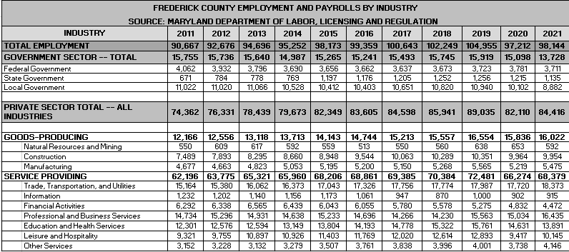

The total number of people employed in Frederick County increased for nine consecutive years between 2011 and 2019. 2020 saw a significant decrease due to the negative impact of the Covid 19 pandemic on the economy. Please note the following chart:

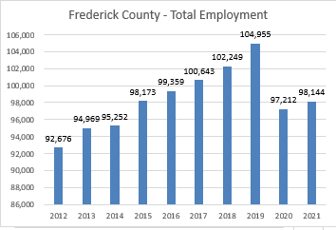

Between 2011 and 2021, the overall government sector employment experienced only modest growth – 15,755 persons in 2011 as compared to 15,913 in 2019. However, the sector shrunk significantly between 2019 and 2021. The number of federal employees declined from 4,062 in 2011 to 3711 in 2021.. However, state government employees increased from 671 in 2011 to 1,135 in 2021 -- representing an 69% increase. Local/municipal employment in Frederick County decreased from 11,022 in 2011 to 10,102 in 2021 – an 8% decrease.

Frederick County’s private sector employment saw increases during the same time period (2011-2019). As with overall employment, private sector employment increased eight consecutive years – increasing by approximately 16.64% -- during this time frame. Again, 2020 saw a significant decrease due to the effects of the pandemic. It rebounded modestly in 2021. Please note the following chart:

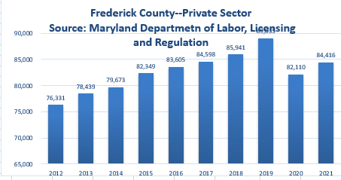

Key drivers of private sector employment growth since 2011 have been increases in the number of people working in the service providing sectors which represent over 78% of the increases since 2011. Eliminating the increases in construction (2,471) from the goods producing sectors provides a net increase of 840 jobs which is just over five percent of the total private sector increases. Please note the following chart:

|  |  |  |
| --- | --- | --- |
| **Area** | | **Net Increase (Decrease)** |
| **Goods Producing** | | **3,311** |
|  | Natural Resources and Mining | 42 |
|  | Construction | 2471 |
|  | Manufacturing | 798 |
| **Service Providing** | | **12,181** |
|  | Trade, Transportation, and Utilities | 3209 |
|  | Information | (317) |
|  | Financial Activities | (1,820) |
|  | Professional and Business Services | 1701 |
|  | Education and Health Services | 1590 |
|  | Leisure and Hospitality | 6824 |
|  | Other Services | 994 |
| **Total Private Sector Increases** | | **15,492** |

Areas of private sector decline include financial activities and information, the result of continuing consolidation in each of these industries. The following chart reflects the top employers in Frederick County, according to the Frederick County Office of Economic Development, 2023:

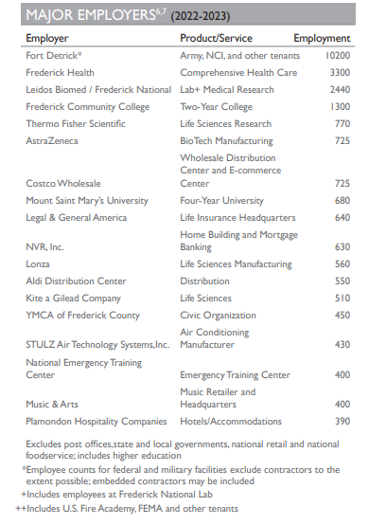

Source: Maryland Department of Commerce, Brief Economic Facts, Frederick County, Maryland

**Housing**

In 2022 Frederick County had a total of 99,891 households with an average household size of 2.7. [4] Frederick City had a total of 106,417 housing units estimated in 2021. The median value of a home in Frederick County in 2021 was $356,500 and in Frederick City $289,000 (2021).

**Frederick County Government**

Frederick County transitioned from the County Commissioner form of government to the County Charter form of government on December 1, 2014.  Under Charter Government, there is an Executive Branch with a County Executive and a Legislative Branch with a County Council.

The County Executive establishes the long-term vision for Frederick County and ensures effective and efficient services to county residents.  The County Executive provides management oversight and direction for Frederick County Government departments and agencies, establishes public policy, and is responsible for the development of the county budget. The County Executive serves a four-year term and not more than two consecutive terms.

The seven-member County Council consists of five members elected by district and two elected at large. They also serve four-year terms -- no more than three consecutive terms. Council members will have the power to initiate legislation.

Frederick County has twelve municipalities: [Brunswick](http://msa.maryland.gov/msa/mdmanual/37mun/brunswick/html/b.html), [Burkittsville](http://msa.maryland.gov/msa/mdmanual/37mun/burkittsville/html/b.html), [Emmitsburg](http://msa.maryland.gov/msa/mdmanual/37mun/emmitsburg/html/e.html), [Frederick](http://msa.maryland.gov/msa/mdmanual/37mun/frederick/html/f.html), [Middletown](http://msa.maryland.gov/msa/mdmanual/37mun/middletown/html/m.html), [Mount Airy](http://msa.maryland.gov/msa/mdmanual/37mun/mountairy/html/m.html), [Myersville](http://msa.maryland.gov/msa/mdmanual/37mun/myersville/html/m.html), [New Market](http://msa.maryland.gov/msa/mdmanual/37mun/newmarket/html/n.html), [Rosemont](http://msa.maryland.gov/msa/mdmanual/37mun/rosemont/html/r.html), [Thurmont](http://msa.maryland.gov/msa/mdmanual/37mun/thurmont/html/t.html), [Walkersville](http://msa.maryland.gov/msa/mdmanual/37mun/walkersville/html/w.html), and [Woodsboro](http://msa.maryland.gov/msa/mdmanual/37mun/woodsboro/html/w.html). Frederick was the first locality to incorporate in Frederick County in 1816. It was followed by Emmitsburg (1824), Thurmont (1831), Middletown (1833), Woodsboro (1836), New Market (1878), Brunswick (1890), Walkersville (1892), Burkittsville (1894), Mount Airy (1894), Myersville (1904), and Rosemont (1953).

**Economic Development**

The City of Frederick Department of Economic Development is an active organization tasked with increasing economic opportunities for Frederick residents through job creation, revitalization, and reinvestment. This mission is achieved through four strategic priorities: job creation, business infrastructure advocacy, downtown revitalization, and key corridor revitalization.

Business attraction and retention is a core function of DED. The City works in partnership with Frederick County Business Development and Retention Department (BDRD) and the Maryland Department of Business and Economic Development (DBED), to attract business to Frederick. Outreach efforts include regional and national trade shows targeted at bioscience and technology; targeted regional advertising that focuses on bioscience, technology, manufacturing and site selection consultants; and participation in and sponsorship of key industry events hosted by groups such as the Tech Council of Maryland and Maryland/DC Chapter of NAIOP.

Business retention and expansion is a key focus. Studies by the International Economic Development Council (IEDC) show that 65-80% of new jobs in a community are created by the existing businesses. Retention and expansion efforts include business retention visits; attendance at local business events such as the Frederick County Chamber of Commerce activities; local advertising and trade shows; and support for expanding businesses as they navigate the development review and permit process.

Downtown Frederick, serving as the County Seat, is home to more than 600 businesses and 5,000 employees. Downtown is also the hub of culture and tourism, attracting more than 1.4 million visitors annually. As a major economic engine within the City, continued revitalization, reinvestment and adaptive reuse of historic buildings are key economic development goals for DED.

The City's retail and business corridors also serve as valuable economic engines. Revitalization and reinvestment in traditional retail corridors and the surrounding neighborhoods are critical DED initiatives that strengthen both the business community and quality of life in Frederick.

**Education**

Frederick County offers a wide variety of public and private educational opportunities for its residents – which include pre-primary through graduate school. Frederick County is nationally recognized for its public education system and remains one of the region's leaders in virtually every measure of student achievement and educational attainment. [Frederick County Public Schools (FCPS)](http://www.fcps.org) has been a recipient for many years of the US Department of Education's prestigious national Blue Ribbon Schools of Excellence Award and Maryland Public Schools rank first in the Nation for the 4th year in a row in 2011 by Education Week Magazine. Also in 2011, Michelle Shearer, an Urbana High School Teacher and FCPS employee was named National Teacher of the Year.

**2023 Frederick County Public School Statistics:**

1. Total Enrollment – 46,889
2. Total Schools - 69
   1. 38 Elementary
   2. 13 Middle
   3. 10 High
   4. 8 Special
3. Graduation Rate – 93%
4. Dropout Rate – 2.6%

***Source:*** [*March 2023- Frederick County Public School*](http://fcps.schoolwires.com/fcps/lib/fcps/publications/FCPSwinter09_10.pdf)***s (FCPS.org)***

**Private Schools**

1. [The Banner School](http://www.bannerschool.org), Frederick
2. [The Barnesville School](http://www.barnesvilleschool.org), Frederick
3. [Beth Sholom Day School](http://www.bethsholomfrederick.org), Frederick
4. Catoctin View Mission School, Thurmont
5. [Frederick Adventist School](http://fredericksdachurch.org), Frederick
6. [Frederick Christian Academy](http://www.fcamd.org), Frederick
7. Frederick Montessori School, Frederick
8. [Friends Meeting School](http://www.friendsmeetingschool.org), Ijamsville
9. Grace Baptist Academy, Brunswick
10. [Lucy School: An Arts-Based School](http://www.lucyschool.com), Middletown,
11. [Mother Seton School](http://www.mothersetonschool.org), Emmitsburg
12. [New Life Christian School](http://www.newlifecs.org), Frederick
13. [St. John Regional Catholic School](http://www.sjrcs.org), Frederick
14. [St. John's Catholic](http://www.stjph.org/) Prep, Buckeystown
15. [St. Thomas More Academy](http://www.stthomasmoreacademy.org), Middletown
16. [Walkersville Christian Family School](http://www.wcfs.edu), Thurmont

**Special Education Schools**

1. [Maryland School for the Deaf](http://www.msd.edu) offers educational opportunities for deaf and hard-of-hearing students.
2. [Rock Creek School](http://schools.fcps.org/amain/mainpage.cfm?bcid=1024) serves those students with severe physical, mental, intellectual, emotional, hearing, visual, and learning disabilities.
3. [The Jefferson School](http://thejeffersonschool.org) offers educational opportunities for children and adolescents with emotional, social or learning disabilities.
4. [Sylvan Learning Center](http://www.educate.com) provides tutoring services in Frederick County.
5. [Huntington Learning Center](http://www.huntingtonlearning.com) tutors students from kindergarten through college.

**Higher Education**

A comprehensive array of advanced education alternatives is offered by local colleges, including Hood College, Mount Saint Mary's University and Frederick Community College as well as by prestigious universities such as Johns Hopkins University and the 13 campuses of the University System of Maryland. [Hood College](http://www.hood.edu/) in Frederick City is a private, four-year college offering 27 undergraduate majors and 13 graduate programs. In Emmitsburg, [Mount Saint Mary's University](http://www.msmary.edu/) is an undergraduate liberal arts college with graduate programs that include business and education. [Frederick Community College,](http://www.frederick.edu) also in Frederick City, is a two-year college offering associate degrees in a variety of majors, including business, pre-engineering and nursing. More than 300,000 students are enrolled in approximately 65 accredited institutions of higher education in the Baltimore-Washington area.

**Workforce Training**

The workforce development system in Frederick County works together to proactively promote and implement the needs of its ever-changing workforce. [Frederick Community College](http://www.frederick.edu) (FCC) has numerous partnerships and is capable of customizing various industries training needs. The [Frederick County Business and Employment Center](http://www.frederickworks.com) provides various levels of training, which range from seminars, hands on computer-labs to working with Frederick Community College and the customized training programs. [Maryland Department of Business & Economic Development](http://www.mdbusiness.org/) (DBED) provides reimbursements grants for the development and training of new employees in firms locating or expanding their workforce in Maryland. The newest workforce initiative in the area is the [Frederick County Business Roundtable for Education](http://www.frederickchamber.org/CWT/external/wcpages/programs/FCBRE.aspx), a 501c(3) that helps develop strong connections between classroom learning and the business community and promotes academic excellence.

**Healthcare**

[Frederick Healthcare](http://www.fmh.org) is an accredited 276-bed hospital that provides for medical/surgical, pediatric, psychiatric, obstetric, sub-acute, and emergency patients and is a Level III A Neonatal Intensive Care facility. Its 400-physician staff specialize in all areas of medicine. In addition to their main campus on 7th Street, FHH has opened branch locations at the FSK Mall, Rose Hill Plaza on Opossumtown Pike, FHH South along New Design Road, FHH Crestwood, FHH-Mt. Airy, the new health campus on Monocacy Boulevard, as well as several locations to serve the residents of southern Frederick County.

A full range of medical care can be found within the Frederick community through private practice as well. From general practitioners, obstetrics, dermatology, radiology, dialysis, holistic health care providers and more, there is an abundance of quality care available for area residents. Both Children's Hospital and John's Hopkins have opened Frederick facilities as well.

**Tourism**

Tourism has a tremendous impact on Frederick City and County. According to the Tourism County of Frederick County, in 2019 approximately 2.1 million visitors spent $426.1 million while on excursion in Frederick County. Tourism also accounts for nearly 6,800 industry-related jobs. One of the chief attractions is downtown Frederick’s 40-block historic district, with its nationally renowned architecture, variety of historic sites, retailers and antique shops, and 40 restaurants along Restaurant Row. Nearly three-quarters of all visitors to Frederick County come to downtown Frederick during their journey – about 1.4 million tourists each year.

Other notable visitor attractions throughout the City and downtown include the National Museum of Civil War Medicine, Frederick County Historical Society and Roger Brooke Taney House, Mt. Olivet Cemetery and the grave of Francis Scott Key, and Harry Grove Stadium – home to the Frederick Keys, the Baltimore Orioles’ minor league affiliate

**Recreation**

The City of Frederick maintains 57 municipal parks totaling 422 acres of recreational pleasure. City parks include Baker Park, Carroll Creek Park, Hillstreet Skate Park, Diggs Pool, and many neighborhood parks. The city also owns and manages the William Talley Fitness Center, which offers affordable fitness facilities and fitness classes.

In addition, the City of Frederick is home to the Frederick Keys, a minor league baseball team affiliated with the Baltimore Orioles. The Frederick Keys play all of their home games at the Harry Grove Stadium, which is owned by the City of Frederick. This stadium was constructed in 1990 and seats 5,400 fans.

**Agriculture**

The agricultural industry is a vital part of Frederick County’s economy and quality of life. The large agricultural base covers 188,576 acres of farmland. This makes Frederick County the largest agricultural county in Maryland, accounting for 10% of Maryland's total farmland. There are more than 1300 farms in Frederick County accounting for the largest number of farms in the state. Frederick County ranks number one in Maryland for turkeys, cattle, agritourism farms, and third for equine inventory. The total value of sales that Frederick County farmers produce is almost $130 million annually. Agricultural producers in the county have expanded production of Nursery and greenhouse crops as well as Christmas trees.

**Public Safety**

The Frederick Police Department is a full service, nationally accredited police agency providing police services. The FPD provides an array of multi-faceted police services through multiple divisions. Fire and Rescue Services are managed through the Frederick County Division of Fire and Rescue Services Division. Frederick City has six Fire Stations located within the Frederick City limits and 28 throughout Frederick County.

**NEIGHBORHOOD DATA**

The subject property is located just east of the Town of Emmitsburg. The Town of Emmitsburg is located in the northwestern portion of Frederick County, proximate to the border with Pennsylvania. Emmitsburg is close to Baltimore, Maryland (57 miles southeast), Harrisburg, Pennsylvania (49 miles northeast), Washington D.C. (78 miles southeast), Frederick, Maryland (24 miles south), Hagerstown, Maryland (27 miles west), Thurmont, Maryland (7 miles south), and Gettysburg, Pennsylvania (12 miles north).

Emmitsburg is situated at the eastern edge of the Catoctin Mountain Range, which provides recreational and scenic opportunities. Emmitsburg lies in the middle of a Maryland-designated Civil War Heritage Area. In addition, Emmitsburg is home to the FEMA National Training Center, Mt. St. Mary's University, and the historic home of St. Elizabeth Ann Seton. Emmitsburg's population in 2020 was 2,770 people, according to U.S. Census data and the Frederick County Division of Planning calculations. Emmitsburg’s population declined by 44 residents between 2010 and 2020. As of 2022, Emmitsburg had a total of 1,083 households, which was an increase from 1,070 households in 2010.

Please note the following satellite image of the subject neighborhood, with the subject property noted with a red marker:

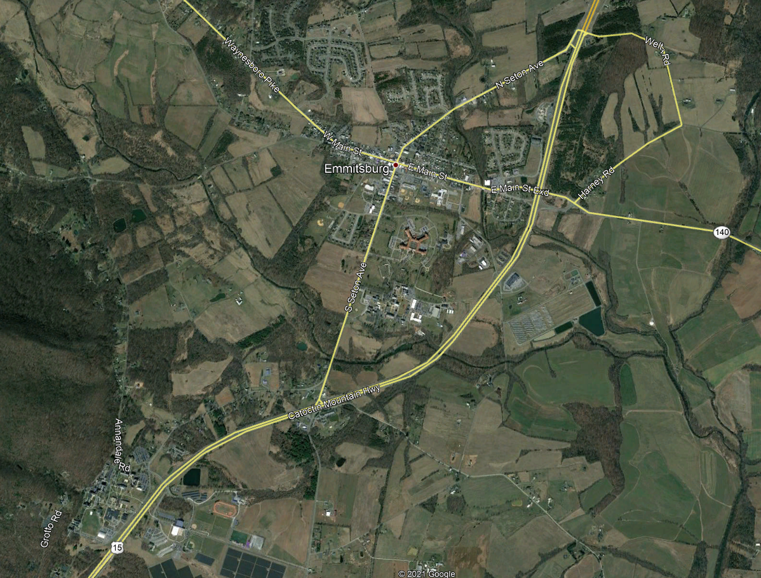

As noted previously, the site is located within U.S. Census Tract 7668.00. The following table summarizes 2023 estimates for this tract:

|  |  |
| --- | --- |
| **Census Tract: 23224-24-021-7668.00 Summary** | |
| Tract Income Level | Moderate |
| 2020 Estimated Median Family Income | $129,092 |
| Tract Population | 5,827 |
| Number of Households | 1,530 |
| 1-4 Family Units | 1,451 |
| Owner-occupied units | 1,099 |

**Census Tract Map:**

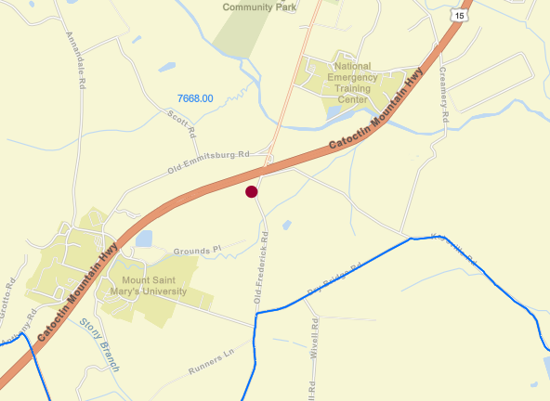

During the past few years there has been considerable residential and commercial growth within Emmitsburg. Residential development in the northwest section has grown exponentially in the last few years and commercial development has also seen increases. The recent improvements to the downtown (expanded bridge over Flat Run, sidewalk improvements, and square corner improvements) are enticing investment into the central district, which is having a positive impact on the other commercial sectors along U.S. Route 15.

According to demographic information reflected on CoStar, the population within one mile is expected to grow in the next five years – from 2,398 persons to 2,537. Please note the CoStar demographic report below:

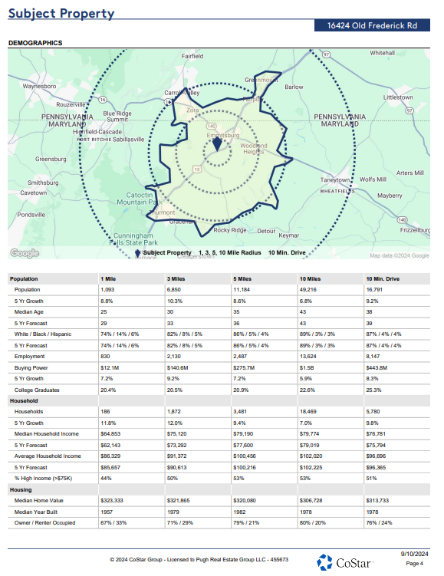

In addition, these data from CoStar reflect that within one mile of the subject property, the average median household income is $65,764.

The dominate feature of the neighborhood is Maryland Route 15, which is an interstate, four-lane roadway that provides ready access to Pennsylvania, Maryland, and Virginia. Daily traffic counts in the area of the subject range between 20,191 and 25,351 vehicles. Please note the following daily traffic count map from the Maryland Department of Transportation:

**Maryland Department of Transportation: Daily Traffic Count Map (Northern Frederick County)**

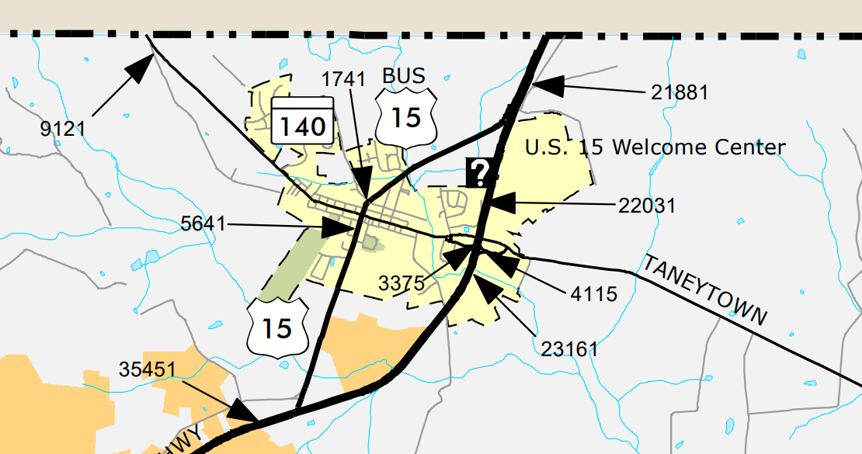

**REAL ESTATE TAX ANALYSIS**

The subject property is located within Frederick County, Maryland. Article 15 of the Declaration of Rights of Maryland’s Constitution requires that all real property is assessed and taxed uniformly. State law specifically requires that all taxable property shall be assessed based on its fair market value. The Maryland Department of Assessments and Taxation is responsible for appraising all real property and business personal property within the entire State of Maryland. Properties are appraised once every three years and property owners are notified of any change in their assessed value. Assessments are certified by the Department to local governments where they are converted into property tax bill by applying the appropriate property tax rates. Property tax rates vary widely. No restrictions or limitations on property taxes are imposed by the State, enabling cities and counties to set tax rates at the level required to fund governmental services. These rates can increase, decrease, or remain the same from year to year. If the proposed tax rate increases the total property tax revenues, the governing body must advertise that fact and hold a public hearing on the new tax rate. This is called the Constant Tax Yield Rate process.

The overall tax rate is a combination of State, county, and Emmitsburg. Property taxes are expressed as a dollar amount per $100 of assessed value. The following chart reflects the assessed value effective 01/01/2021:

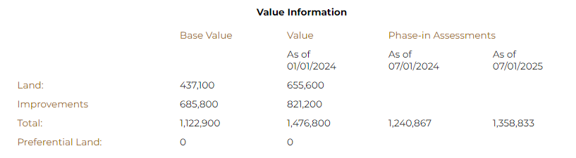

The property is subject to taxes levied by the State of Maryland and Frederick County. Frederick County taxes include an Urban Fire/Rescue tax and System Benefit Charge which is administered by the Frederick County Waste Management Division. The purpose of the charge is to pay a portion of the reasonably anticipated capital costs and operating costs for the disposal of solid waste. The charge is applied countywide, including within the municipalities. All information for the assessment of a property is based on the Maryland State Department of Assessments and Taxation’s (SDAT) records.

Reflected on the following page is the current real estate tax bill and charges.

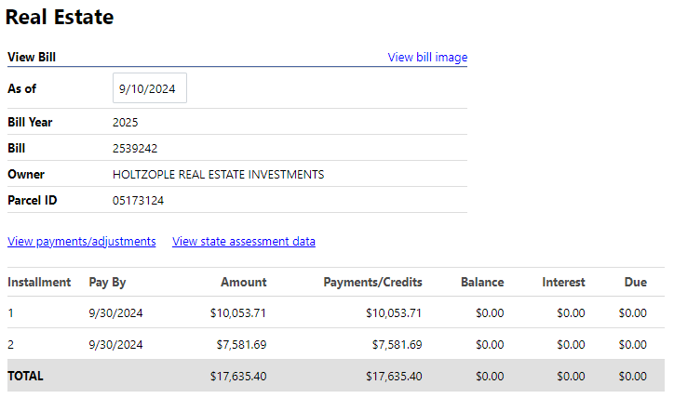

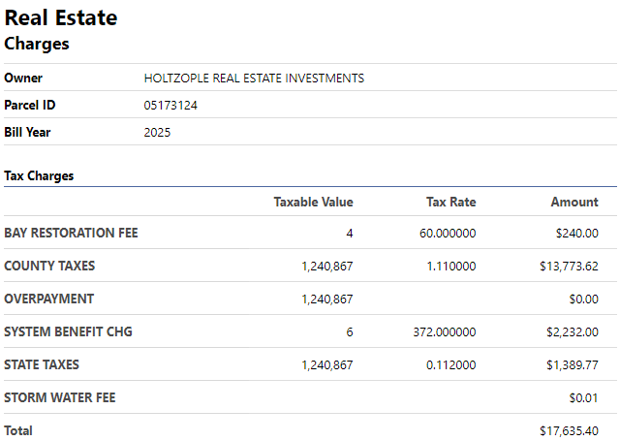

As of the appraisal effective date, all taxes due have been paid.

**MARKET ANALYSIS**

The value of real estate is affected by the convergence of the ongoing changes in social, economic, governmental, and physical forces – which typically occur in a cyclical pattern. Real estate markets are dynamic and the typical life cycle includes the following stages:

* Growth—a period during which the market area gains public favor and acceptance
* Stability—a period of equilibrium without marked gains or losses
* Decline—a period of diminishing demand
* Revitalization—a period of renewal, redevelopment, modernization, and increasing demand

To determine the influence of economic forces on value, market participants analyze the relationships between current and anticipated supply and demand and the economic ability of the prospective purchasers. However, real estate markets differ significantly from the markets for other goods and services and have never been considered truly efficient markets. Real estate products are heterogeneous and changes in supply lag behind changes in demand for a specific real estate product because of the time needed to bring a new building to market. In a more efficient market, like a stock exchange, supply quickly reacts to changes in demand.[5]

The coronavirus pandemic disrupted typical economic activity (growth) locally, nationally, and throughout much of the developed world. It had a transformative impact on several real estate market segments – particularly retail, office, and restaurants; but at the same time increasing demand for other property types – particularly industrial, warehouse/flex, and suburban residential.

**Federal Open Market Committee**

The Federal Open Market Committee (FOMC) is probably the most extensively used and most potent of the Federal Reserve’s credit-regulating devices. The FOMC buys and sells US government securities in the open market, thereby exerting a powerful influence on the supply of money and the interest rate. The FOMC consists of twelve members—the seven members of the Board of Governors of the Federal Reserve System; the president of the Federal Reserve Bank of New York; and four of the remaining eleven Reserve Bank presidents, who serve one-year terms on a rotating basis. The rotating seats are filled from the following four groups of Banks, one Bank president from each group: Boston, Philadelphia, and Richmond; Cleveland and Chicago; Atlanta, St. Louis, and Dallas; and Minneapolis, Kansas City, and San Francisco. Nonvoting Reserve Bank presidents attend the meetings of the Committee, participate in the discussions, and contribute to the Committee’s assessment of the economy and policy options. In fact, through its daily operations, the FOMC maintains short-term money rates at selected target levels. In periods of economic crisis, the Fed supplies financial markets with necessary liquidity.

On July 31, 2024, the Federal Open Market Committee released a statement summarizing the key economic indicators of the United States: “Recent indicators suggest that economic activity has continued to expand at a solid pace. Job gains have moderated, and the unemployment rate has moved up but remains low. Inflation has eased over the past year but remains somewhat elevated. In recent months, there has been some further progress toward the Committee's 2 percent inflation objective.

The Committee seeks to achieve maximum employment and inflation at the rate of 2 percent over the longer run. The Committee judges that the risks to achieving its employment and inflation goals continue to move into better balance. The economic outlook is uncertain, and the Committee is attentive to the risks to both sides of its dual mandate.

In support of its goals, the Committee decided to maintain the target range for the federal funds rate at 5-1/4 to 5-1/2 percent. In considering any adjustments to the target range for the federal funds rate, the Committee will carefully assess incoming data, the evolving outlook, and the balance of risks. The Committee does not expect it will be appropriate to reduce the target range until it has gained greater confidence that inflation is moving sustainably toward 2 percent. In addition, the Committee will continue reducing its holdings of Treasury securities and agency debt and agency mortgage‑backed securities. The Committee is strongly committed to returning inflation to its 2 percent objective.

In assessing the appropriate stance of monetary policy, the Committee will continue to monitor the implications of incoming information for the economic outlook. The Committee would be prepared to adjust the stance of monetary policy as appropriate if risks emerge that could impede the attainment of the Committee's goals. The Committee's assessments will take into account a wide range of information, including readings on labor market conditions, inflation pressures and inflation expectations, and financial and international developments.”

**National Employment Data**

According to the U.S. Department of Labor (August 2, 2024), total nonfarm payroll employment edged up by 114,000, the U.S. Bureau of Labor Statistics reported. Employment continued to trend up in health care, in construction, and in transportation and warehousing, while information

lost jobs.

This news release presents statistics from two monthly surveys. The household survey measures labor force status, including unemployment, by demographic characteristics. The establishment survey measures nonfarm employment, hours, and earnings by industry. For more information about the concepts and statistical methodology used in these two surveys, see the Technical Note.

**Survey Data**

Total nonfarm payroll employment increased by 142,000 in August, and the unemployment rate changed little at 4.2 percent, the U.S. Bureau of Labor Statistics reported today. Job gains occurred in construction and health care.

Construction employment rose by 34,000 in August, higher than the average monthly gain of 19,000 over the prior 12 months. Over the month, heavy and civil engineering construction added 14,000 jobs, and employment in nonresidential specialty trade contractors continued to trend up (+14,000).

Health care added 31,000 jobs in August, about half the average monthly gain of 60,000 over the prior 12 months. In August, employment rose in ambulatory health care services (+24,000) and hospitals (+10,000).

In August, employment in social assistance continued its upward trend (+13,000) but at a slower

pace than the average monthly gain over the prior 12 months (+21,000). Individual and family

services added 18,000 jobs over the month.

Employment in manufacturing edged down in August (-24,000), reflecting a decline of 25,000 in durable goods industries. Manufacturing employment has shown little net change over the year.

Employment showed little change over the month in other major industries, including mining, quarrying, and oil and gas extraction; wholesale trade; retail trade; transportation and warehousing; information; financial activities; professional and business services; leisure and hospitality; other services; and government.

In August, average hourly earnings for all employees on private nonfarm payrolls increased by 14 cents, or 0.4 percent, to $35.21. Over the past 12 months, average hourly earnings have increased by 3.8 percent. In August, average hourly earnings of private-sector production and nonsupervisory employees increased by 11 cents, or 0.4 percent, to $30.27. (See tables B-3 and B-8.)

The average workweek for all employees on private nonfarm payrolls edged up by 0.1 hour to 34.3 hours in August. In manufacturing, the average workweek changed little at 40.0 hours, and overtime edged up by 0.1 hour to 3.0 hours. The average workweek for production and nonsupervisory employees on private nonfarm payrolls remained at 33.7 hours. (See tables B-2 and B-7.)

**National Gross Domestic Product**

Real gross domestic product (GDP) increased at an annual rate of 1.4 percent in the first quarter of 2024, after increasing 3.4 percent in the fourth quarter of 2023.  Please note the following chart from the U.S. Bureau of Economic Analysis:

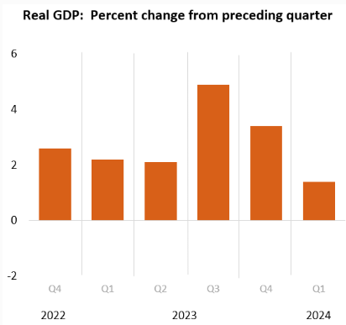

**Maryland Summary**[6][1]

Maryland payroll employment increased by 6,100 jobs (0.2 percent), on net, in July. Professional and business services (3,600 jobs) experienced the largest month-over-month increase in jobs followed by trade, transportation, and utilities.

On a year-over-year basis, Maryland payroll employment increased by 16,700 jobs (0.6 percent), on net. The most jobs were added over the year in government (17,500 jobs), followed by education and health services (10,000 jobs).

The unemployment rate in Maryland remained stable over the month at 2.8 percent in July and has risen 0.9 percentage point from its July 2023 reading of 1.9 percent.

Residential permits decreased by 15.1 percent from May 2024 to June 2024; however, compared to a year ago, June 2023, Maryland has seen permits increase by 13.3 percent.

According to the Federal Housing Finance Agency, the value of homes in Maryland appreciated by 1.5 percent in Q1 of 2024 compared to Q4 of 2023. Compared to Q1 of 2023, home values appreciated by 6.8 percent in Q1 of 2024.

**ZONING**

The subject property is zoned General Industrial (G‑I). The General Industrial District is intended to provide areas of industries involving manufacturing or processing and for those industrial uses which cannot meet the performance criteria of the Limited Industrial (L‑I) District. The maximum permitted sound levels in decibels (dB) in a residential district is 55 db and 64 dB in a commercial district, and in a light industrial district lot adjacent to a noise source is 75 dB. The following shows the subject property relative to the zoning maps provided by the Frederick County Department of Planning:

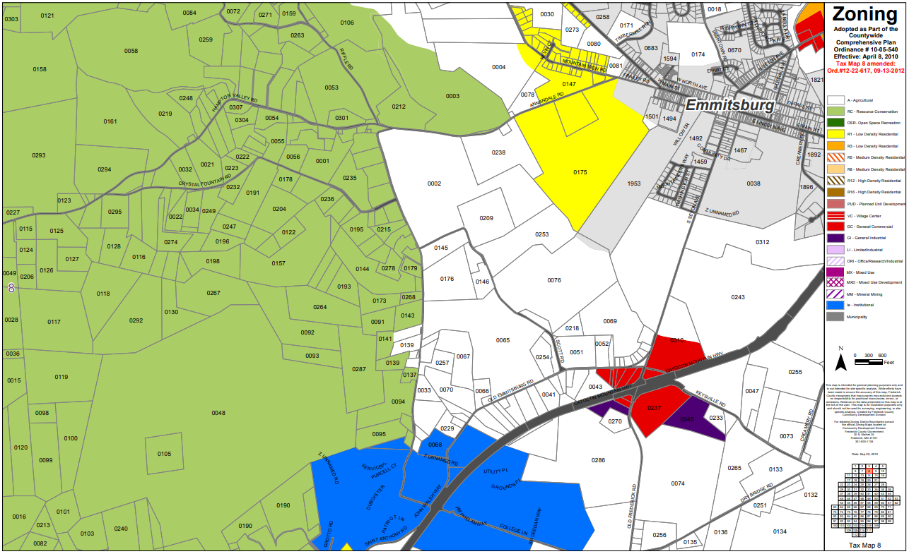

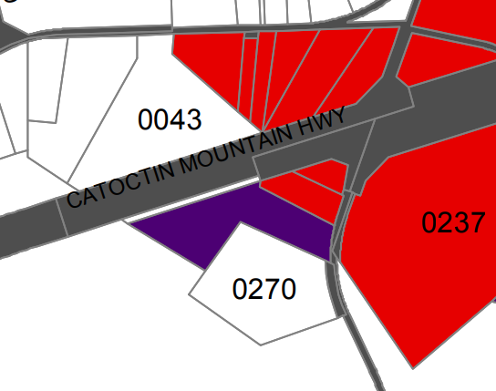 

**The subject property’s existing use complies with the zoning ordinance.**

Commercial uses permitted subject to site development plan approval are auction house, boat sales and service, farm equipment sales or service, feed and grain mills, furniture repair, lumber yard, mobile home sales, and stone monument sales.

Commercial, business and personnel services permitted subject to site development plan approval are broadcasting studio, communication towers, bus depots, printing and upholstery, medical clinics, and offices.

Wholesaling and processing permitted subject to site development plan approval include agricultural products processing, bottling plant, building contractors and material storage yard, carpet and rug cleaning, petroleum products storage, laboratory research (experimental or testing), industrial laundry and dry cleaning, stone monument processing, wholesaling and/or warehouse, yard storage, recycling operations, recycling pick‑up and distribution center.

Automobile and related services permitted subject to site development plan approval are automobile filling and service station, automobile repair or service shop, sales and service center, storage tanks (gasoline), truck stop and filling service station facilities, motor freight terminals.

Industrial uses permitted subject to site development plan approval are limited manufacturing and assembly uses and general manufacturing.

In the General Industrial District the minimum lot area for all permitted uses is 1 acre. For open space uses there is no minimum and for governmental and public utilities 1 acre is the minimum.

The lot width for all permitted uses is 150 ft. The front yard set‑back is 25 ft. and the side yard set‑back is 15 ft. The rear yard set‑back is 40 ft. and the maximum height is 60 ft.

For governmental and public utilities, the lot width is 200 ft., front yard set‑back is 40 ft., the side yard set‑back is 40 ft., the rear yard set‑back is 40 ft., and the maximum height is 30 ft.

**SITE DATA**

The subject site has a total of 4.46 acres or 194,278 square feet of land. The site is irregularly shaped and has approximately 173 feet of frontage on Old Frederick Road which is an asphalt improved two lane road maintained by Frederick County. The subject site has approximately 745 feet of front on Maryland Route 15, but the site does not have direct access. Access to Maryland Route 15 is via Old Frederick Road. The site is generally flat. A satellite image of the subject site is reflected below. I've noted the approximate property lines with a red dotted line:

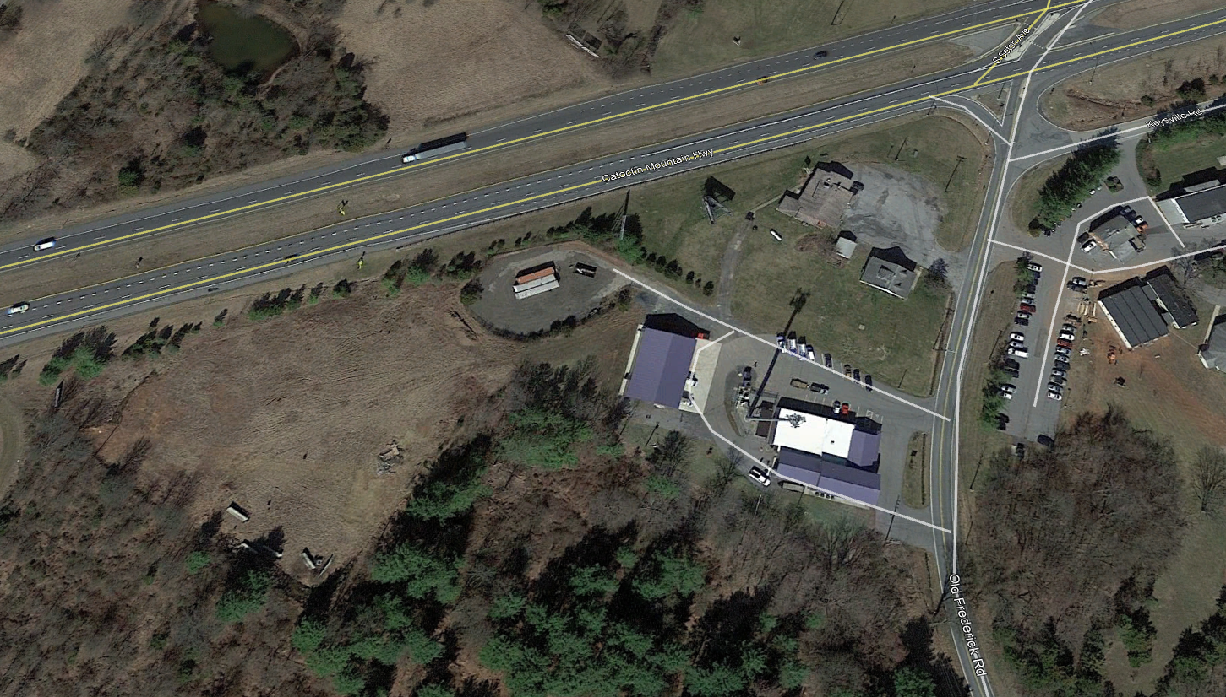

Former Oil storage area now used for material storage

Storage Building

Vehicle Access

Main Building

Cellular Tower

Route 15

There are two asphalt aprons that provide vehicular access to the site from Old Frederick Road. The site has private well and septic, utilities available to the site are electricity and telephone service.

The site has asphalt parking area located in front and on the north side of the building. The site is also improved with a cellular tower, which encumbers 1,699 square feet of site area in a perpetual easement and 2,639 square feet of site area in an access easement. The easement site area is located directly behind the main building. The access easement is located between the main building and Old Frederick Road along the north property line. The easements were granted to American Tower, L.P. on March 10, 2011 and recorded in Liber 8530/Folio 413 of the Frederick County land records. The following site plan (from the recorded deed) reflects the easement areas:

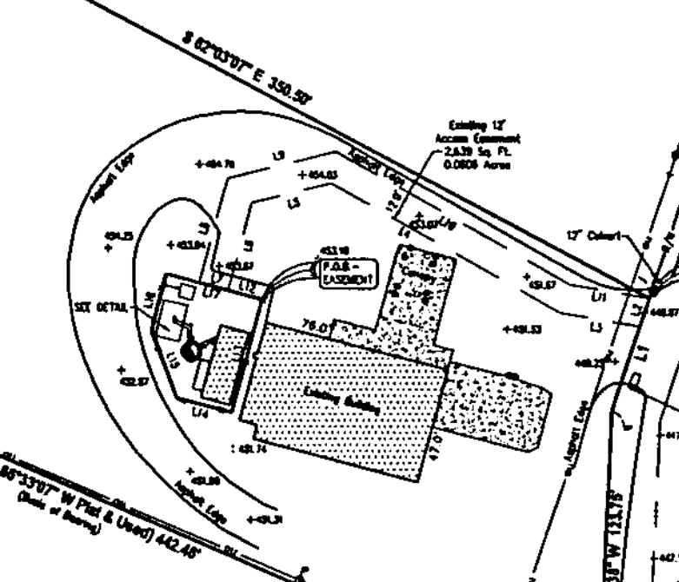

Access Easement Area

Cellular Tower Area

Soil tests were not provided, but it was assumed by me that there are no soil or sub-soil conditions could limit use or prevent development of the site. In addition, there are no apparent adverse easements or encroachments that would adversely affect the marketability of the subject site. The following are environmental factors observed during the property inspection:

1. Cleanliness/orderliness of operations.

**Overall, the site is in average condition.**

1. Standpipes, vents, ground subsidence, or other indications of underground storage tanks.

**Underground tanks supporting the former gas station were removed in October 2007. In addition, the site formerly was used as a home heating oil distribution center, which were located in the area now used for material storage. The above ground tanks were removed in 2013. This report assumes that the site has not been damaged as a result of their being on site, which wasn’t evident during my site visit.**

1. Denuded or dead vegetation indicating spills or dumping.

**None observed.**

1. Discoloration of soil indicating spills or dumping.

**None observed.**

1. Standing water or leading pipes, valves, or containers indicating defective storage facilities.

**None observed.**

1. Unusual smells or noxious odors inside or outside of any building.

**None observed.**

1. Signs of explosions or chemical spills.

**None observed.**

1. Storage barrels, drums, or containers filled with liquid chemicals.

**There were two small oil storage tanks along the north façade of the storage building. They appeared to be in good condition and no evidence of leaking was observed.**

1. Refuse piles, incinerators, dump areas or abandoned vehicles.

**None observed.**

1. Wetlands, bogs, or lakes on or near the property.

**None observed.**

1. General topography of the site.

**Generally flat.**

1. Indications of asbestos to the best of my ability.

**None observed.**

1. Mounds or depressions which might indicate buried substances.

**None observed.**

1. Electrical equipment or transformers.

**None observed.**

1. Unexplained vehicle tracks indicating unreported disposal activity.

**None observed.**

The following site data was gathered during the property inspection and independent analysis:

|  |  |  |  |
| --- | --- | --- | --- |
| **SITE ELEMENT** | **DATA** | **SITE ELEMENT** | **DATA** |
| **Approach** | County dedicated two lane asphalt improved roadway. | **Waterfront/Wetlands** | None |
| **Access** | Two 35’ asphalt aprons provides ingress/egress access to site. | **Nuisances(s)** | None observed. |
| **Hazards** | None observed |
| **Contamination** | None observed |
| **Surrounding Uses** | Light industrial, retail, residential, agricultural. | **Restrictive Covenants** | None |
| **Frontage** | 175 feet on Old Frederick Road. Along Maryland Route 15, the site has approximately 735 feet of frontage. The road frontage does not include access but it does provide the site with considerable vehicle site view. | **Common Elements** | N/A |

|  |  |  |  |  |  |
| --- | --- | --- | --- | --- | --- |
| **SITE ELEMENT** | **DATA** | **SITE ELEMENT** | | | **DATA** |
| **Visibility** | Good | **Easements** | | | The site is also improved with a cellular tower, which encumbers 1,699 square feet of site area in a perpetual easement and 2,639 square feet of site area in an access easement. The easements were granted to American Tower, L.P. on March 10, 2011 in exchange for $250,000 and which was recorded in Liber 8530/Folio 413 of the Frederick County land records. |
| **Size** | 4.46 acres or 194,278 square feet. | **Encumbrances** | | | None |
| **Shape** | Irregular. | **Clouds** | | | None |
| **Topography** | Level with street grade. | **Anticipated Public or private improvements** | | | The site and immediately surrounding area is slated for water and sewer service is 7-10 years according to Frederick County's Division of Public Works. Please note the "Water Service Areas" and "Sewer Service Areas" maps beginning on the next page. |
| **Soils** | Restricted. | **Utilities/Services** | | | Electric, telephone. |
| **Drainage** | Good | | **Excess/Surplus Land** | No. | |
| **Flood Area** | None. Please see FEMA Map number 24021C0054E reflected below. | | **Current Use of Site** | Light assembly, material storage, office. | |
| **Entitlements** | Existing building and site improvements. | | | | |
| **Overall Conclusions** | The site has adequate vehicle access and the design allows for easy ingress and egress of vehicle and light truck traffic. | | | | |

**Frederick County "Water Service Area"**

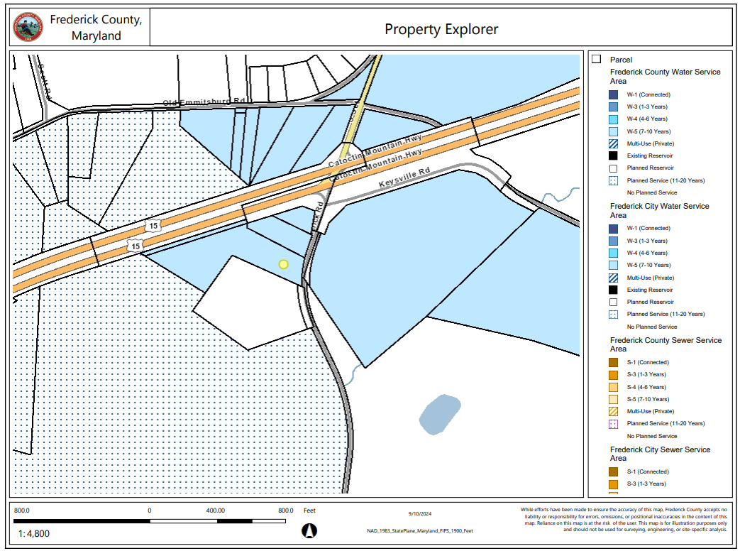

**Frederick County “Sewer Service Area”**

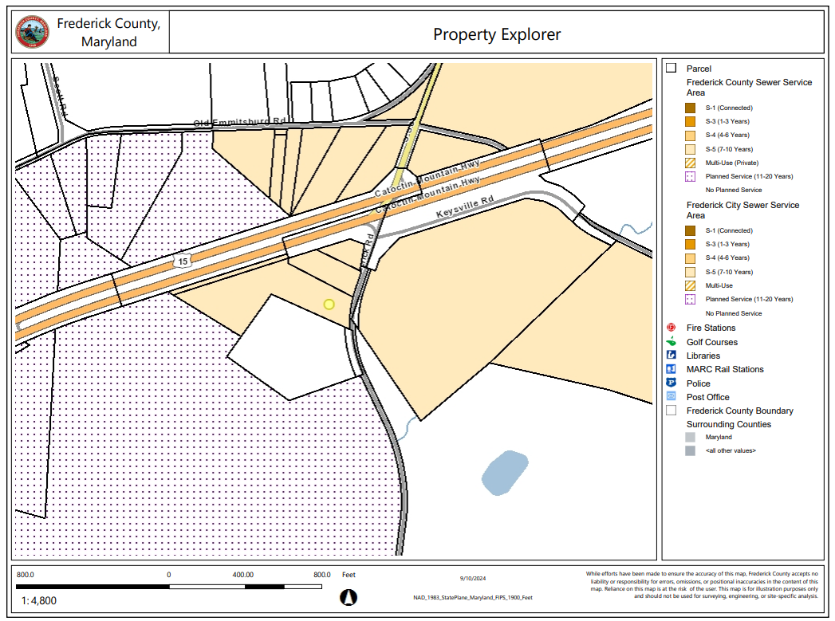

**FEMA Flood Map Number 24021C0065D; Effective Date 8/1/2023.**

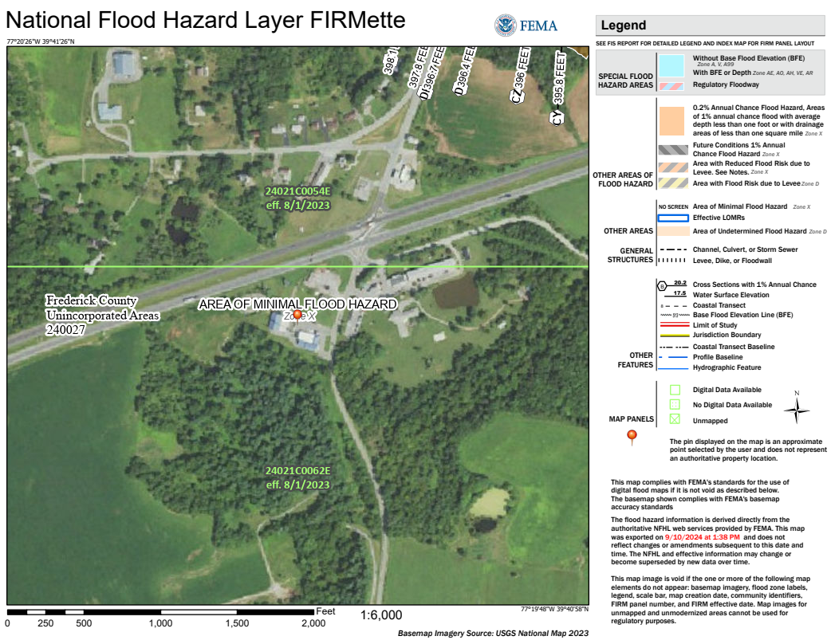

It is important to note that the opinion of value provided in this report assumes that the property is not negatively affected by the existence of hazardous substances or other environmental conditions. Real Estate Appraisers are not experts in the identification of hazardous substances or other environmental conditions. During the property inspection and inquiries of the subject site, the appraisers did not become aware of any information that would lead to the conclusion that any negative environmental conditions exist on the subject property. The presence of contamination could negatively impact our opinion of value.

**DESCRIPTION OF THE IMPROVEMENTS**

At the time of the property inspection, the subject property is improved with two buildings – both used by Holtzople Heating and Air Conditioning service. The first building (“main building”) was originally constructed as an automobile gas/service building in the 1960s and was renovated/expanded in 2014. This building includes 9,310 square feet of gross building area. Since our last appraisal of the subject property in 2021, 500 square feet of gross building area have been converted to office space. The second building is a warehouse that was constructed in 2017. This building includes 4,000 square feet of gross building area. Both buildings rest on a concrete slab and have metal clad exterior facades and roof coverings, with double hung windows with screens.

**Main Building**

This building is a partial two-story structure that includes 7,630 square feet on the first floor, and 1,680 square feet on the second floor. The first floor includes ten offices, restrooms, work areas, employee pantry, server room, two warehouse areas, and a fabrication area. Walls and ceilings in the office area are finished drywall, with flooring that is a combination of laminate and carpet. The employee pantry includes cabinets, full size refrigerator, electric stove/oven combination, dishwasher and single sink. Lighting in the office area is recessed fixtures. Since 2021, 500 square feet of gross building area has been converted to office space.

The warehouse/storage areas have finished concrete floors, with walls and ceilings and a combination of metal panels and painted concrete block. Lighting is from installed fixtures. There is central heating and cooling throughout this building.

The second floor includes 1,680 square feet of gross building area and includes three offices, restrooms, pantry, and conference/training room. Walls and ceiling in this area are finished drywall with recessed light fixtures. The flooring is carpet and the pantry includes cabinets, countertop, and full-size refrigerator. The following table summarizes this building:

|  |  |  |  |
| --- | --- | --- | --- |
| **BUILDING ELEMENT SUMMARY** | | | |
| **Building Age/Year Built** | 1960’s/2014 | **Overall Condition** | Good. |
| **Building Type** | Office/warehouse | **Building Dimensions** | Various. |
| **Building Height (overall)** | ~20 feet. | **Roof System** | Pitched with metal coverings. |
| **Foundation** | Concrete slab | **Building Structure** | Concrete block, metal frame. |
| **Number of levels** | Two (partial) | **Ceiling Height** | Varied. |
| **Gross Building Area (SF)** | 9,310 SF | **Veneer** | Metal panels. |

|  |  |  |  |
| --- | --- | --- | --- |
| **BUILDING ELEMENT SUMMARY** | | | |
| **Sprinkler System** | No. | **Ingress/Egress** | Front: 3'x7' metal glass door and two 10' x 10' overhead garage doors.  North side: One 3'x7' metal door, one 10'x10' overhead garage door; South side: One 3'x7' metal door. |
| **Flooring** | Combination of vinyl and carpet | **Partition Walls** | Drywall |
| **Elevator Access** | None. | **Heating/Air Conditioning Systems** | HVAC throughout. |
| **Overall Construction Quality** | Average | **Lighting** | Recessed fluorescent |
| **Effective Age** | 10 Years | **Remaining Economic Life** | 40 Years |
| **Summary** | The building is well maintained and as a result very little deferred maintenance was observed. The renovation work completed in 2014 provides the owner with a building that matches the functionality required to operate their business effectively. | | |

**Storage Building**

This building is a partial one-story structure that includes 4,000 square feet of gross building area that was constructed in 2017. The building rests on a concrete slab and has wood frame wall and roof (which is pitched) construction. The entire veneer and roof are covered in metal panels. The warehouse has finished concrete floors and the interior walls and ceilings are metal panels with installed lighting fixtures. There is central heating and cooling throughout this building, with the walls and ceiling insulated.

The front of the building includes four 14’ x 14’ insulated overhead garage doorways with a solid metal pedestrian doorway along the front and north facade. The building hasThe following table summarizes this building:

|  |  |  |  |
| --- | --- | --- | --- |
| **BUILDING ELEMENT SUMMARY** | | | |
| **Building Age/Year Built** | 2017 | **Overall Condition** | Good. |
| **Building Type** | Warehouse | **Building Dimensions** | 80’x50’ |
| **Building Height (overall)** | 16 feet. | **Roof System** | Pitched with metal coverings. |
| **Foundation** | Concrete slab | **Building Structure** | Concrete block, wood frame. |
| **Number of levels** | One | **Ceiling Height** | 14’ |
| **Gross Building Area (SF)** | 4,000 SF | **Veneer** | Metal panels. |

|  |  |  |  |
| --- | --- | --- | --- |
| **BUILDING ELEMENT SUMMARY** | | | |
| **Sprinkler System** | No. | **Ingress/Egress** | Front and side: 3'x7' metal pedestrian door and four 14' x 14' overhead garage doors. |
| **Flooring** | Finished concrete. | **Partition Walls** | Metal. |
| **Elevator Access** | None. | **Heating/Air Conditioning Systems** | HVAC throughout. |
| **Overall Construction Quality** | Average | **Lighting** | Installed fluorescent. |
| **Effective Age** | 5 Years | **Remaining Economic Life** | 40 Years |
| **Summary** | The building is well maintained and as a result very little deferred maintenance was observed. | | |

**SUBJECT PROPERTY PHOTOGRAPHS**

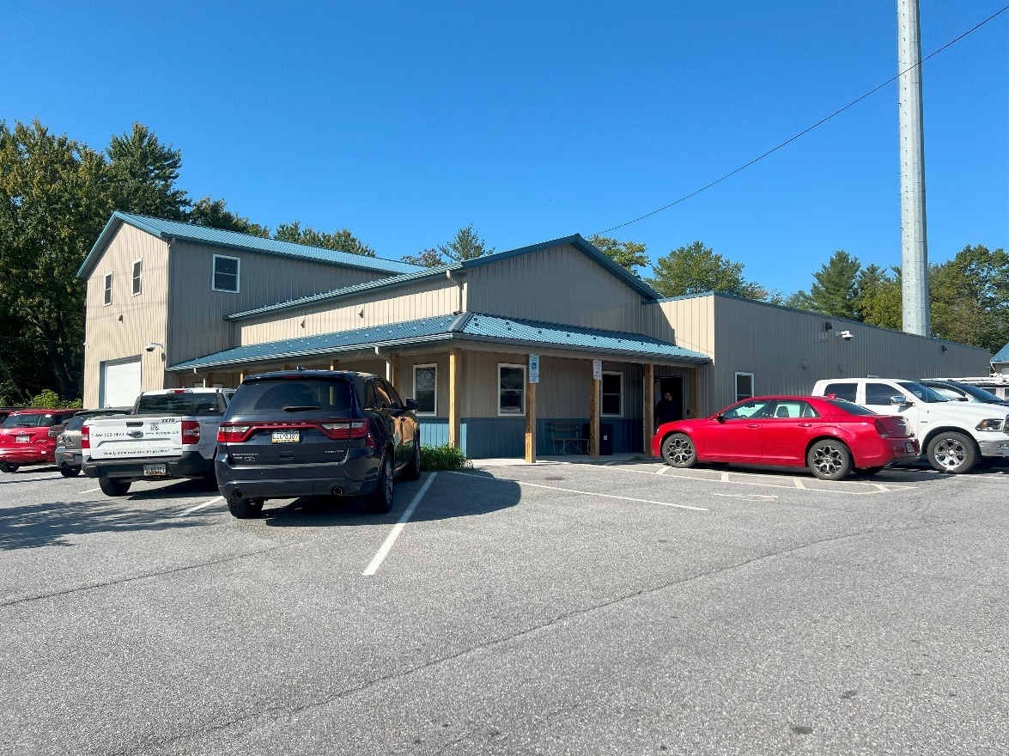

**MAIN BUILDING – FRONT AND NORTH FAÇADE**

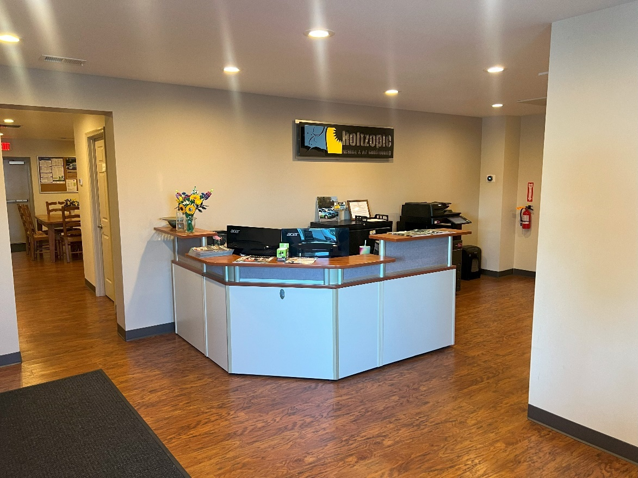

**FIRST FLOOR RECEPTION**

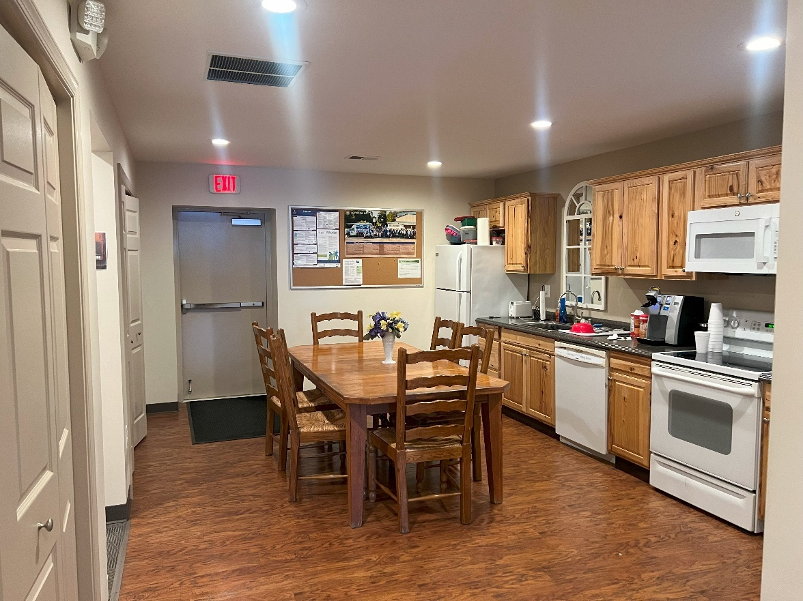

**EMPLOYEE BREAKROOM**

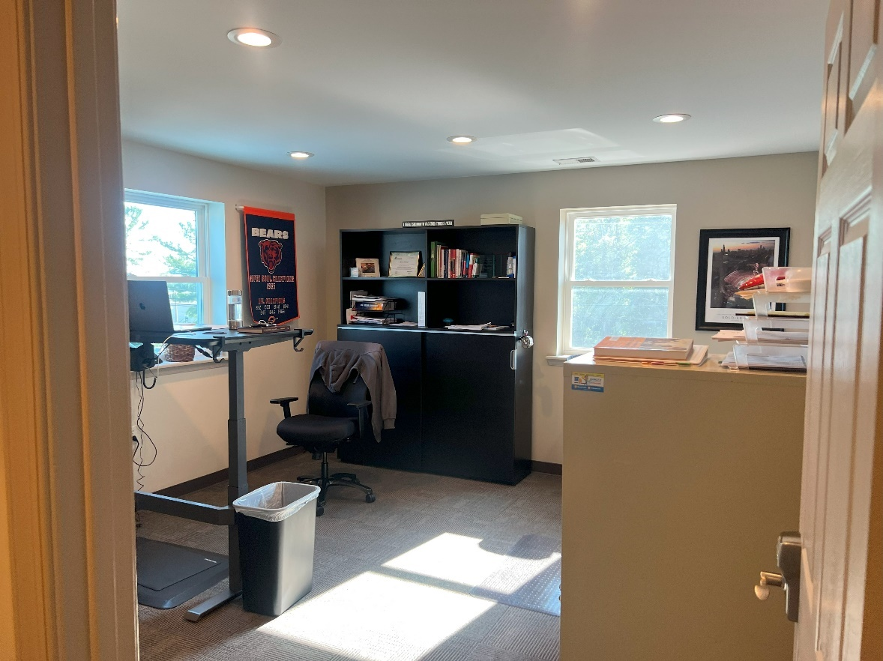

**TYPICAL FIRST FLOOR OFFICE**

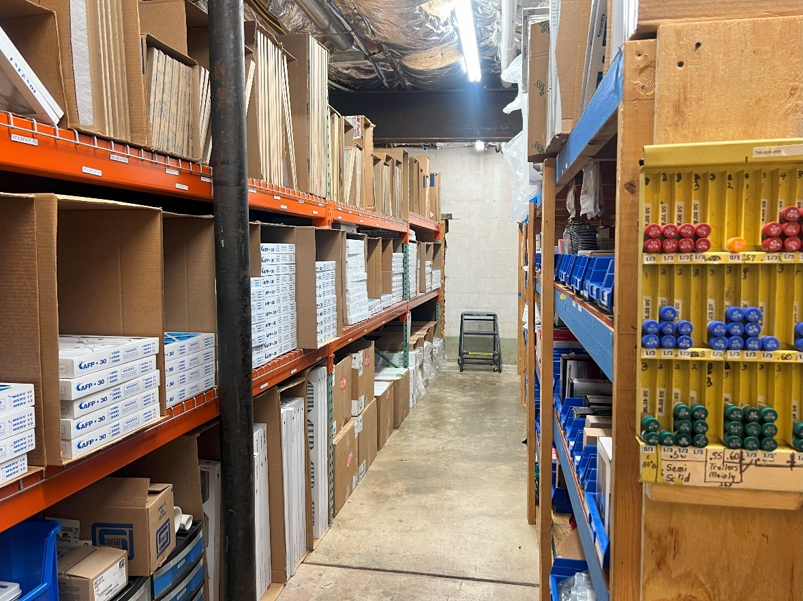

**STORAGE AREA**

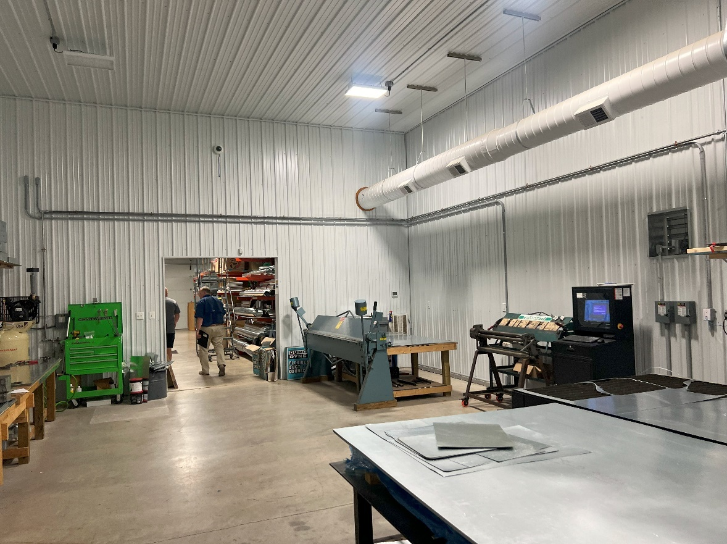

**ASSEMBLY AREA**

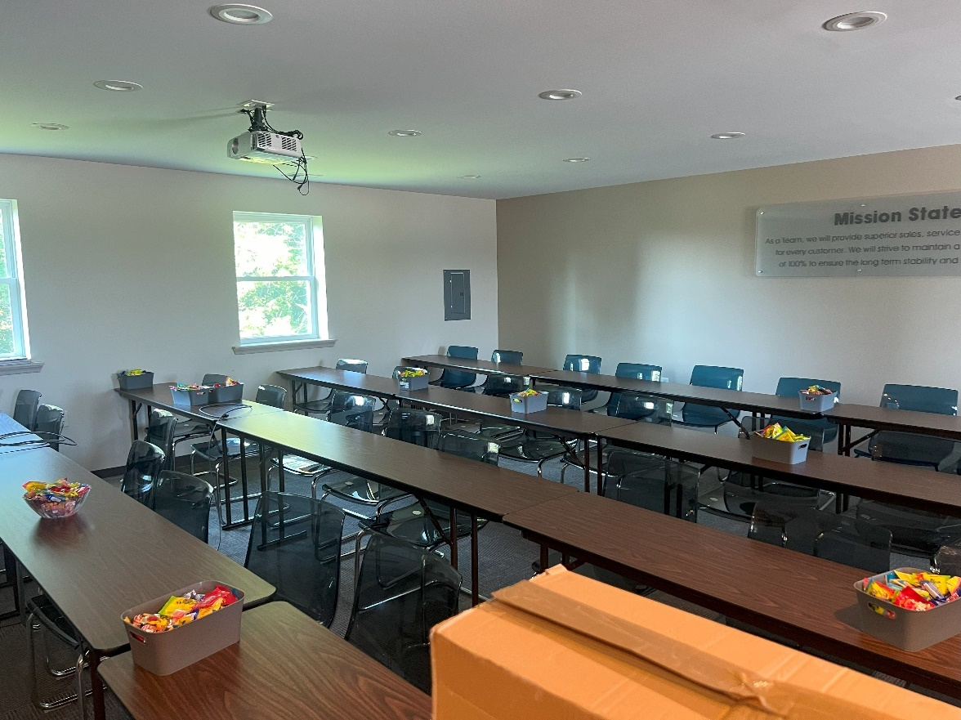

**SECOND FLOOR CONFERENCE/TRAINING AREA**

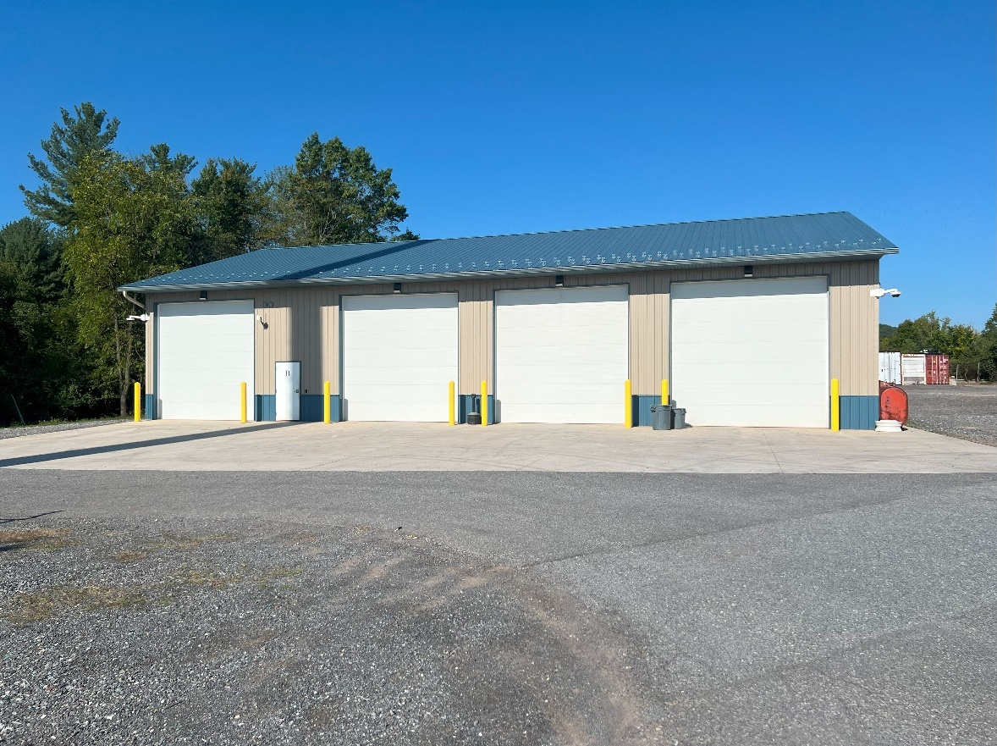

**STORAGE BUILDING**

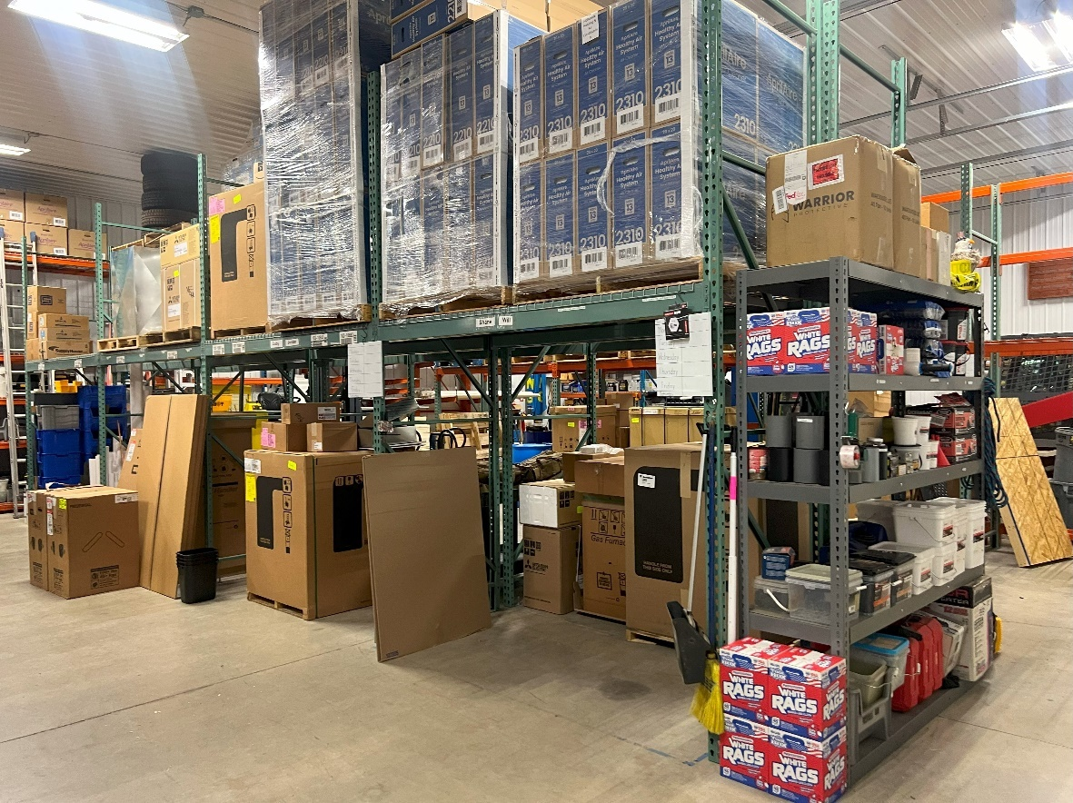

**STORAGE BUILDING INTERIOR**

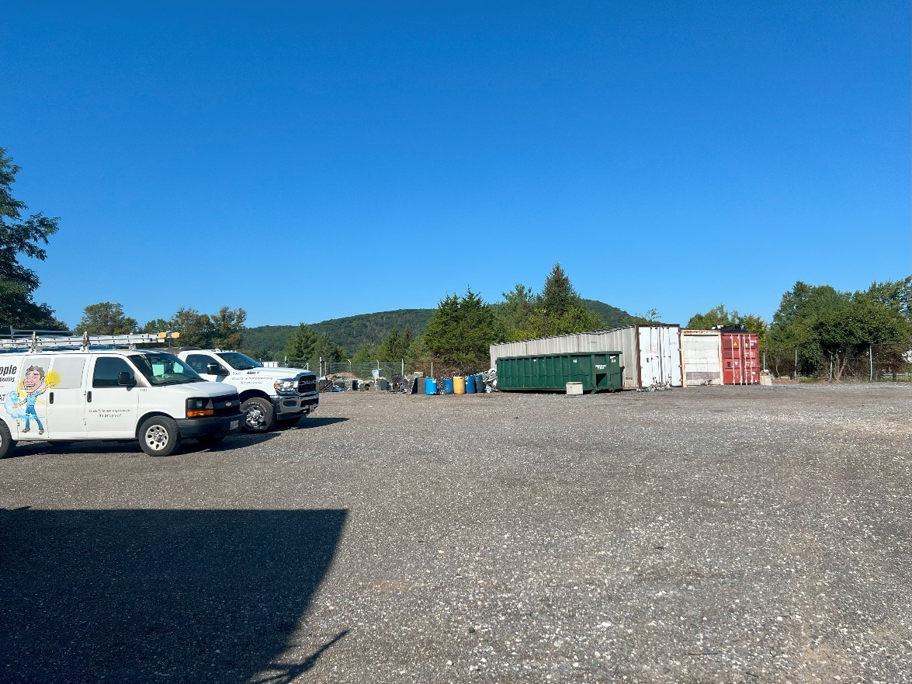

**SITE VIEW – OUTDOOR MATERIAL STORAGE AREA**

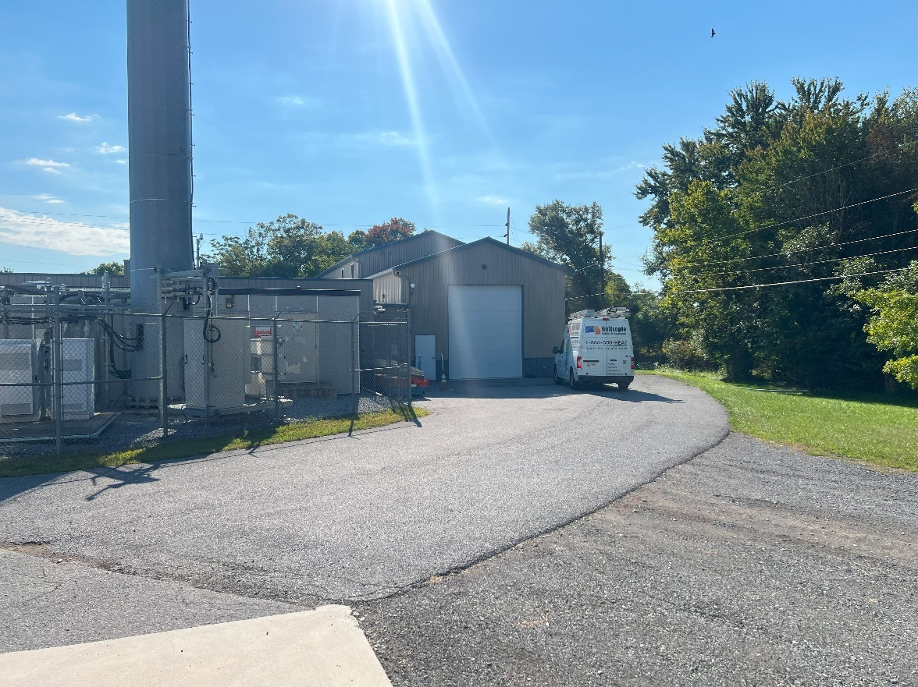

**SUBJECT REAR/LOADING BAY**

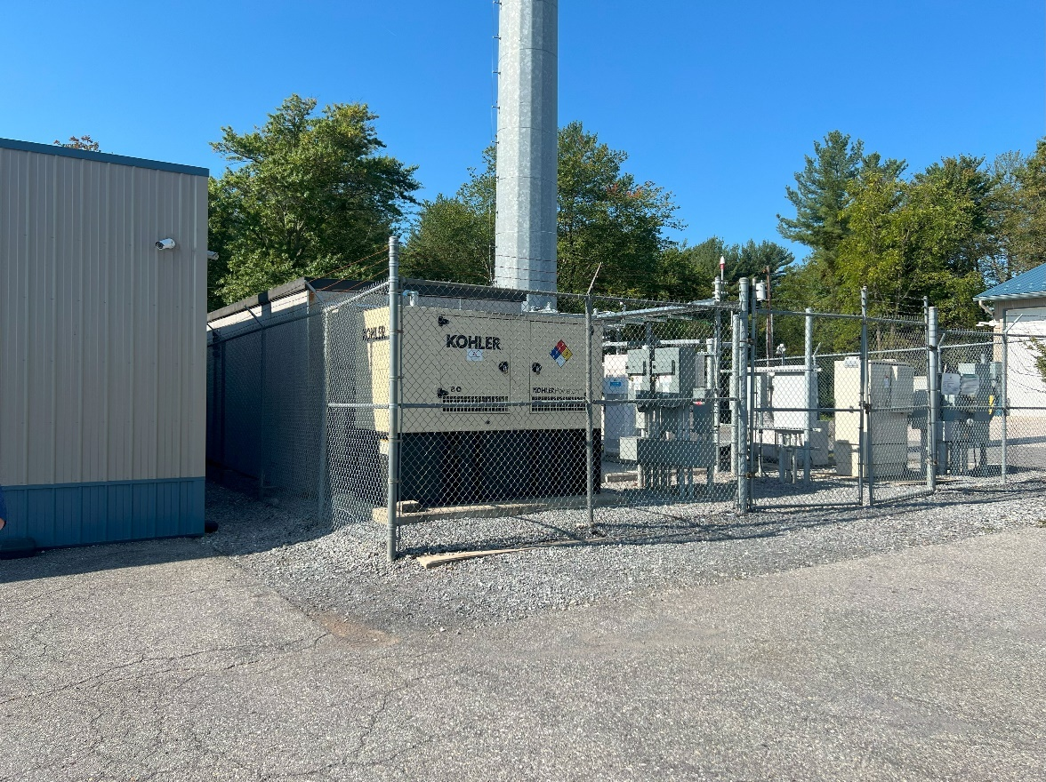

**CELLULAR TOWER EMTRANCE**

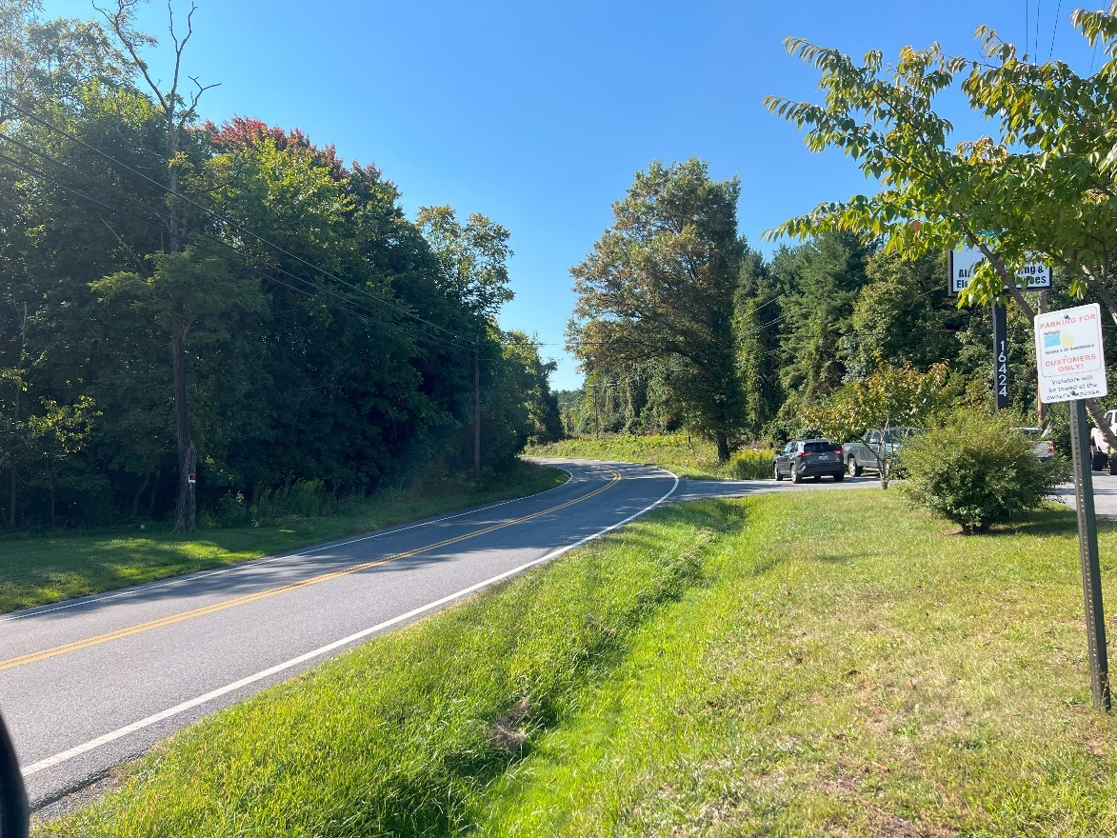

**OLD FREDERICK ROAD LOOKING SOUTH**

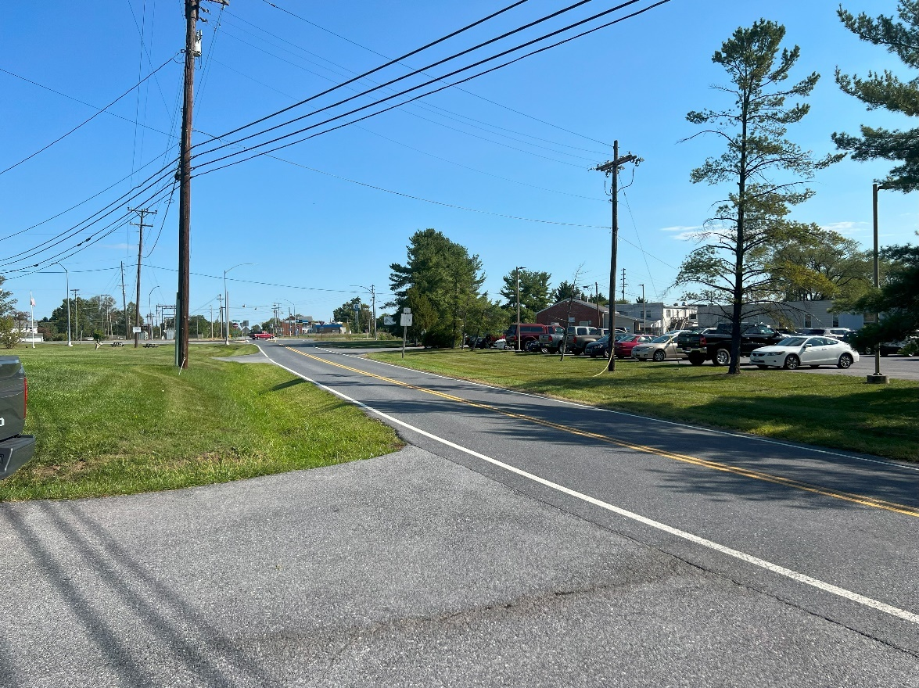

**OLD FREDERICK ROAD LOOKING NORTH**

**HIGHEST AND BEST USE**

Highest and best use may be defined as:

**Highest and best use***. The reasonably probable and legal use of vacant land or an improved property, which is physically possible, appropriately supported, financially feasible, and that results in the highest value.*

In the analysis of pertinent data, four criteria are applied in the following order to develop adequate support for the appraiser’s highest and best use determination:

1. Legally permissible
2. Physically possible
3. Financially feasible
4. Maximally productive

These criteria are generally considered sequentially; however, the tests of physical possibility and legal permissibility can be applied in either order, but they both must be applied before the tests of financial feasibility and maximum productivity.

The process for determining the highest and best use of a property has four main steps. The first two are applied in the analysis of highest and best use of the land or site as though vacant; the third and fourth steps are applied in the analysis of the highest and best use of the property as improved.

1. Determine the highest and best use as of the site as though vacant.
2. Determine the ideal improvement for development of the site.
3. Compare the ideal improvement and the existing improvement.
4. Conclude whether the improvements should be maintained as is or be renovated, converted, or demolished.

I have presented the analysis of the site as though vacant and as improved in the following pages.

**Analysis Of The Site As Though Vacant**

The first step in the highest and best use analysis is to determine what the highest and best use of the subject property would be if the site was vacant land. The highest and best use of the land as though vacant must be considered in relation to its existing use and all potential uses.

Highest and best use analysis builds on the conclusions of the marketability study. The analysis of the land as though vacant focuses on alternative uses, with the appraiser testing each reasonably probable use for legal permissibility, physical possibility, financial feasibility, and maximum productivity.

The highest and best use of land or site as though vacant is concluded after the four criteria have been applied and various alternative uses have been eliminated. The remaining use that fulfills all four criteria is the highest and best use of the land as though vacant. A proper highest and best use conclusion indicates the use, the market participants for the use, and the timing of the use. In addition, the ideal improvement (see definition below) must be determined as a part of highest and best as though vacant.

**Ideal improvement.** *The improvement that takes maximum advantage of the site’s potential given market demand, conforms to current market standards and the character of the market area, and contains the most suitably priced components; the improvement that represents the highest and best use of the land as though vacant.*

The ideal improvement should meet the following criteria:

* Takes maximum advantage of the site’s potential market demand
* Conforms to current market standards and the character of the market area
* Contains the suitably priced components

If an ideal improvement is considered to be the highest and best use of the land as though vacant, it presumably will have no physical deterioration or functional obsolescence. Thus, any difference in value between the existing improvement and the ideal improvement would be attributable to physical deterioration or functional obsolescence. The appraiser must still consider whether external obsolescence is present, which may affect both the existing improvement and the ideal improvement.

|  |  |
| --- | --- |
| **Physical Possibility** | The subject property consists of one parcel (149) that has a total of 4.46 acres or 194,278 square feet of land that is located on Old Frederick Road in an un-incorporated area of Frederick County near the town of Emmitsburg. |
| **Legal Permissibility** | The subject property is zoned General Industrial (G‑I). The General Industrial District is intended to provide areas of industries involving manufacturing or processing and for those industrial uses which cannot meet the performance criteria of the Limited Industrial (L‑I) District. This allows for a wide variety of heavy and light industrial uses subject to site plan approval. |
| **Financial Feasibility** | Warehouse/office buildings are feasible since they provide a positive return to the land. |
| **Maximum Profitability** | Warehouse/office. |
| **Final Analysis** | Warehouse/office. |

**Analysis Of The Site As Improved**

By definition, the highest and best use of the property as improved is: the use that should be made of a property as it exists. An existing property should be renovated or retained as long as it continues to contribute to the total market value of the property, or until the return from a new improvement would more than offset the cost of demolishing the existing building and constructing a new one.

Highest and best use of a property as improved pertains to the use that should be made of an improved property in light of its improvements. Should it be replaced with a different type or intensity of use.

|  |  |
| --- | --- |
| **Legal Permissibility** | The subject property is zoned General Industrial (G‑I). The General Industrial District is intended to provide areas of industries involving manufacturing or processing and for those industrial uses which cannot meet the performance criteria of the Limited Industrial (L‑I) District. This allows for a wide variety of heavy and light industrial uses subject to site plan approval, including the improvements currently on the subject property. |
| **Physical Possibility** | The subject property consists of one parcel (149) that has a total of 4.46 acres or 194,278 square feet of land that is located on Old Frederick Road in an un-incorporated area of Frederick County near the town of Emmitsburg.  At the time of the property inspection, the subject property is improved with two buildings – both used by Holtzople Heating and Air Conditioning service. The first building (“main building”) was originally constructed as an automobile gas/service building in the 1960s and was renovated/expanded in 2014. This building includes 9,310 square feet of gross building area. The second building is a warehouse that was constructed in 2017. This building includes 4,000 square feet of gross building area. |
| **Financial Feasibility** | Currently, the building and site are used by the owner to operate the heating and air-conditioning installation business – warehouse/office and light assembly. Therefore, the current use of the site, as improved, is considered to be financially feasible. |
| **Maximum Profitability** | Continued use as improved. |
| **Final Analysis** | Continued use as improved. |

**VALUATION**

**VALUATION METHODOLOGY**

The valuation process is accomplished through specific steps; the number of steps followed depends on the nature of the appraisal assignment and the data available. The model indicates a pattern that can be used in any appraisal assignment to perform market research and data analysis, to apply appraisal techniques, and to integrate the results of these activities into an estimate of defined value.

Traditionally, appraisal techniques are the specific procedures within the three approaches that are applied to derive indications of real property value. Other procedures such as the use of inferential statistics and economic models also contribute to appraisals. One or more approaches to value may be used depending on their applicability to the particular appraisal assignment.

The ultimate goal of the valuation process is a well-supported value conclusion that reflects all of the factors that influence the market value of the property being appraised. To achieve this goal, an appraiser studies a property from three different viewpoints, which correspond to the three traditional approaches to value.

Approaches Developed:

|  |  |
| --- | --- |
| **SITE VALUATION** | In the valuation process land value estimation is a separate step. The most reliable way to estimate land value is by sales comparison. When few sales are available, however, or when the value indications produced through sales comparison need additional support, other procedures may be used to value land. |
| **COST APPROACH** | A set of procedures through which a value indication is derived for the Leased Fee interest in a property by estimating the current cost to construct a reproduction of, or replacement for, the existing structure; deducting accrued depreciation from the reproduction or replacement cost; and adding the estimated land value plus an entrepreneurial profit. Adjustments may then be made to the indicated Leased Fee value of the subject property to reflect the value of the property interest being appraised. |
| **INCOME APPROACH** | A set of procedures through which an appraiser derives a value indication for an income-producing property by converting it’s anticipated benefits (cash flows and reversion) into property value. This conversion can be accomplished in two ways. One year’s income expectancy can be capitalized at a market-derived capitalization rate or at a capitalization rate that reflects a specified income pattern, return on investment, and change in the value of the investment. Alternatively, the annual cash flows for the holding period and the reversion can be discounted at a specified yield rate. |
| **SALES COMPARISON**  **APPROACH** | A set of procedures in which a value indication is derived by comparing the property being appraised to similar properties that have been sold recently, applying appropriate units of comparison, and making adjustments to the sale prices of the comparables based on the elements of comparison. The sales comparison approach may be used to value improved properties, vacant land, or land being considered as though vacant; it is the most common and preferred method of land valuation when comparable sales data is available. |

**Site Valuation**

The site valuation is performed to derive a value for the underlying land associated with the subject property. Typically, one of four different methods is used for the site valuation

1. Sales comparison
2. Allocation
3. Extraction
4. Income capitalization

Sales comparison is the most common technique for valuing the underlying site as though vacant, and it is the preferred method when comparable sales are available. To apply this method, data on sales of similar parcels of land is collected, analyzed, compared, and adjusted to provide a value indication for the site being appraised.

The allocation method is based on the principle of balance and the related concept of contribution. Both affirm that there is a normal, or typical, ratio of site value to property value for specific categories of real estate in specific locations. The allocation method has its greatest benefit and accuracy when estimating the value of residential lots.

Market extraction is a technique in which site value is extracted from the sale price of an improved property by deducting the contributory value of the improvements, often estimated at their depreciated cost. The remaining value is the value of the site. Improved sales in rural areas are frequently analyzed in this way because the building and site improvements contribute little value in comparison to the underlying site value.

The various income capitalization procedures used to estimate land or site values rely on information that is often difficult for an appraiser to obtain. The two most common income capitalization methods are the land residual technique and ground rent capitalization. The land residual technique is used almost exclusively in the highest and best use analysis to test the productivity of alternate uses of the site as though vacant. The ground rent capitalization procedure is useful when an analysis of comparable sales of leased land indicates a range of rents and capitalization rates.

Since the cost approach was abandoned, the site valuation was not necessary.

**COST APPROACH**

Like the sales comparison and income capitalization approaches, the cost approach to value is based on market comparisons. In the cost approach, the appraiser analyzes the cost of the subject improvements by comparison to the cost to develop similar or exact improvements as evidenced by the cost of construction of substitute properties with the same utility as the subject property. The estimate of cost is adjusted for market-extracted losses in value caused by the age, condition, and utility of the subject improvements or for location problems. Next, the land value is added. The sum of the value of the land and the improvements is adjusted for the property rights conveyed based on market comparisons.

The principle of substitution, the underlying rationale of this approach, holds that no prudent person will pay more for a property than the price of a site and the cost of constructing, without undue delay, an equally desirable and useful property.

In the cost approach, the following steps are typically employed:

1. Estimate the value of the site as though vacant and available to be developed to its highest and best use.
2. Determine which cost basis is most applicable to the assignment: reproduction cost or replacement cost.
3. Estimate the direct (hard) and indirect (soft) costs of the improvements as of the effective appraisal date.
4. Estimate the appropriate entrepreneurial profit or incentive from analysis of the market.
5. Add the estimated direct costs, indirect costs, and entrepreneurial profit or incentive to arrive at the total cost of the improvements.
6. Estimate the amount of depreciation in the structure and, if necessary, allocate it among the three major categories:

* Physical deterioration
* Functional obsolescence
* External obsolescence

1. Deduct estimated depreciation from the total cost of the improvements to derive an estimate of their depreciated cost.
2. Estimate the contributory value of any site improvements that have not already been considered.
3. Add site value to the total depreciated cost of all the improvements to develop the market value of the property.
4. Adjust the value conclusion if any personal property (e.g., furniture, fixtures, and equipment) or intangible assets are included in the appraisal assignment. If necessary, this value, which reflects the value of the Leased Fee interest, may be adjusted for the property interest being appraised to arrive at the indicated value of the specified interest in the property.

Definitions of terms that may be used in the cost approach analysis include:

Breakdown method. *A method of estimating depreciation in which the total loss in the value of a property is estimated by analyzing and measuring each cause of depreciation (physical, functional, and external) separately.*

Cost approach. *A set of procedures through which a value indication is derived for the Leased Fee interest in a property by estimating the current cost to construct a reproduction of (or replacement for) the existing structure, including an entrepreneurial incentive, deducting depreciation from the total cost, and adding the estimated land value. Adjustments may then be made to the indicated Leased Fee value of the subject property to reflect the value of the property interest being appraised.*

Curable functional obsolescence. *An element of depreciation; a curable defect caused by a flaw in the structure, materials, or design, which can be practically and economically corrected.*

Curable physical deterioration. *A form of physical deterioration that can be practically and economically corrected as of the date of appraisal.*

Depreciation. *In appraising, a loss in property value from any cause; the difference between the cost of an improvement on the effective date of the appraisal and the market value of the improvement on the same date.*

Direct costs. *Expenditures for the labor and materials used in the construction of improvements; also called hard costs.*

Economic age-life method. *A method of estimating depreciation in which the ratio between the effective age of a building and its total economic life is applied to the current cost of the improvements to obtain a lump-sum deduction; also known as the age-life method.*

Economic life. *The period over which improvements to real property contribute to property value.*

Entrepreneurial incentive. *The amount an entrepreneur expects to receive for his or her contribution to a project. Entrepreneurial incentive may be distinguished from entrepreneurial profit (often called developer’s profit) in that it is the expectation of future profit as opposed to the profit actually earned on a development or improvement.*

External obsolescence. *An element of depreciation; a diminution in value caused by negative externalities and generally incurable on the part of the owner, landlord, or tenant.*

Functional obsolescence. *The impairment of functional capacity of a property according to market tastes and standards.*

Incurable functional obsolescence. *An element of depreciation; a defect caused by a deficiency or super-adequacy in the structure, materials, or design that cannot be practically or economically corrected.*

Incurable physical deterioration. *A form of physical deterioration that cannot be practically or economically corrected as of the date of appraisal.*

Indirect costs. *Expenditures or allowances for items other than labor and materials that are necessary for construction but are not typically part of the construction contract. Indirect costs may include administrative costs; professional fees; financing costs and the interest paid on construction loans; taxes and the builder’s or developer’s all-risk insurance during construction; and marketing, sales, and lease-up costs incurred to achieve occupancy or sale. Also called soft costs.*

Physical deterioration. *The wear and tear that begins when a building is completed and placed into service.*

Physical life. *The total period a building lasts or is expected to last as opposed to its economic life.*

Quantity survey method. *A cost-estimating method in which the quantity and quality of all materials used and all categories of labor required are estimated and unit cost figures are applied to arrive at a total cost estimate for labor and materials.*

Reproduction cost. *The estimated cost to construct, at current prices as of the effective date of the appraisal, an exact duplicate or replica of the building being appraised, using the same materials, construction standards, design, layout, and quality of workmanship and embodying all the deficiencies, super-adequacies, and obsolescence of the subject building.*

Unit-in-place method. *A cost-estimating method in which total building cost is estimated by adding together the unit costs for the various building components as installed; also called the segregated cost method.*

Useful life. *The period of time over which a structure or a component of a property may reasonably be expected to perform the function for which it was designed.*

Due to the age of the improvements, this approach was abandoned.

**INCOME CAPITALIZATION APPROACH**

In the income approach, the present value of the future benefits of property ownership is measured. A property’s income and resale value upon reversion may be capitalized into a current, lump-sum value. There are two methods of income capitalization: direct capitalization and yield capitalization. In direct capitalization, the relationship between one year’s income and value is reflected in either a capitalization rate or an income multiplier. In yield capitalization, the relationship between several years’ stabilized income and a reversionary value at the end of a designated period is reflected in a yield rate. The most common application of yield capitalization is discounted cash flow analysis.

In this appraisal report, the direct capitalization method of income capitalization was used. In direct capitalization, a single year’s net operating income is divided by an overall capitalization rate to arrive at an indication of value. The general formula for the income approach is as follows:

1. Estimate the potential gross income (PGI).

2. Estimate the vacancy and collection loss.

3. Subtract the vacancy and collection loss from the potential gross income to derive the effective gross income.

4. Estimate the total operating expenses for the subject and deduct them from the effective gross income to derive net operating income (IO).

5. Estimate an overall capitalization rate (RO).

6. Divide the net operating income by the overall capitalization rate to derive a value indication by the income capitalization approach.

Definitions that may be used in the income capitalization approach analysis are as follows:

Direct capitalization. *A method used to convert an estimate of a single year’s income expectancy into an indication of value in one direct step, either by dividing the net income estimate by an appropriate capitalization rate or by multiplying the income estimate by an appropriate factor. Direct capitalization employs capitalization rates and multipliers extracted or developed from market data. Only a single year’s income is used. Yield and value changes are implied but not identified.*

Effective gross income (EGI). *The anticipated income from all operations of the real property after an allowance is made for vacancy and collection losses and an addition is made for any other income.*

Income capitalization approach. *A set of procedures through which an appraiser derives a value indication for an income-producing property by converting its anticipated benefits (cash flows and reversion) into property value. This conversion can be accomplished in two ways. One year’s income expectancy can be capitalized at a market-derived capitalization rate or at a capitalization rate that reflects a specified income pattern, return on investment, and change in the value of the investment. Alternatively, the annual cash flows for the holding period and the reversion can be discounted at a specified yield rate.*

Net operating income (IO). *The actual or anticipated net income that remains after all operating expenses are deducted from effective gross income but before mortgage debt service and book depreciation are deducted.*

Operating expenses. *The periodic expenditures necessary to maintain the real property and continue production of the effective gross income, assuming prudent and competent management.*

Potential gross income (PGI). *The total income attributable to real property at full occupancy before vacancy and operating expenses are deducted.*

Vacancy and collection loss. *A deduction from potential gross income (PGI) made to reflect income reductions due to vacancies, tenant turnover, and nonpayment of rent; also called vacancy and credit loss or vacancy and contingency loss. Often vacancy and collection loss is expressed as a percentage of potential gross income and should reflect the competitive market. Its treatment can differ according to the interest being appraised, property type, capitalization method, and whether the property is at stabilized occupancy.*

The following several pages outline my analysis in the development of the income approach.

**Step 1. Estimate the potential gross income (PGI).**

At the time of the property inspection, the subject property is improved with two buildings – both used by the owner -- Holtzople Heating and Air Conditioning service. The first building (“main building”) was originally constructed as an automobile gas/service building in the 1960s and was renovated/expanded in 2014. This building includes 9,310 square feet of gross building area. The second building is a warehouse that was constructed in 2017. This building includes 4,000 square feet of gross building area. Total gross building area is 13,310 square feet of gross building area.

**COMPARABLE LEASES**

Next, I reviewed several leases of similar properties in the Frederick area to project market terms. The following provides comparable rental data for the leases used in my analysis. Rental rates reflected in these data reflect a range of current rents between $12.60 and $14.94 with the terms of all comparables being Modified Gross. The following pages contain information regarding the referenced rent comparables.

|  |  |
| --- | --- |
| **LEASE COMPARABLE** **1**  **PRG Reference: 02-2011-50000-002** | |
|  | |
| **LEASE PHOTO** | |
| **Property Identification** | |
| Address | 93 Monocacy Blvd |
| Unit | A-13 |
| City, State | Frederick, Maryland |
| **Building Information** | |
| Type | Warehouse/Flex |
| Building SF | 32,461 / Estimated |
| Condition | Very Good |
| Tenancy | Office/Warehouse |
| Year Built | 1986 |
| Site Size | 10.1 acres. |
| Parking | Shared with other tenants. |
| **Lease Information** | |
| Tenant Name | Loud Industries LLC |
| Tenant Use | Warehouse |
| Leased Area (SF) | 2,080 |
| Start Date | 4/15/2024 |
| Rent/SF | $12.00 |
| Term | 5 years |
| Escalation | 3% annually |
| Lease Type | NNN |
| Landlord Responsibilities | Management, structural repairs. |
| Tenant Responsibilities | Prorata share of real estate taxes, building insurance, CAM |
| Confirmation Source | Nancy Green, broker |
| **Comments** | |
| Building constructed in 2022. Tenant uses leased space for manufacturing and distribution. | |

|  |  |
| --- | --- |
| **LEASE COMPARABLE** **2**  **PRG Reference: 02-2011-50000-002** | |
|  | |
| **LEASE PHOTO** | |
| **Property Identification** | |
| Address | 7415 Grove Rd |
| Unit | NA |
| City, State | Frederick, Maryland |
|  | |
| Type | Warehouse/Flex |
| Building SF | 14,400 |
| Condition | Very good |
| Tenancy | Auto-Related, Retail, Warehouse |
| Year Built | 1966 |
| Site Size | 43,124 SF |
| Parking | Yes, 25 spaces |
|  | |
| Tenant Name | ATD Solar |
| Tenant Use | Warehouse |
| Leased Area (SF) | 14,400 (entire building and site) |
| Start Date | 4/1/2024 |
| Rent/SF | $11.00 |
| Term | 5 years |
| Escalation | 3% annually |
| Lease Type | NNN |
| Landlord Responsibilities | Management, structural repairs. |
| Tenant Responsibilities | Prorata share of real estate taxes, building insurance, CAM |
| Confirmation Source | Tony C. Checchia, broker |
| **Comments** | |
| Tenant uses building as a window film business. The second floor is an attic used as storage space. Building was constructed in 1966. | |

|  |  |
| --- | --- |
| **LEASE COMPARABLE** **3**  **PRG Reference: 02-2011-50000-002** | |
|  | |
| **LEASE PHOTO** | |
| **Property Identification** | |
| Address | 1528 Tilco Drive |
| Unit | Unit 2 |
| City, State | Frederick, Maryland |
| **Building Information** | |
| Type | Warehouse/Flex |
| Building SF | 8,142 |
| Condition | Good |
| Tenancy | Office/Warehouse |
| Year Built | 2022 |
| Site Size | 1.23 acres |
| Parking | Yes, shared. |
| **Lease Information** | |
| Tenant Name | College Hunks Junk Removal |
| Tenant Use | Office/warehouse |
| Leased Area (SF) | 3,458 (approximately half of the building and site) |
| Start Date | 4/1/2023 |
| Rent/SF | $14.50 |
| Term | 5 years |
| Escalation | 3% annually |
| Lease Type | NNN |
| Landlord Responsibilities | Management, structural repairs. |
| Tenant Responsibilities | Prorata share of real estate taxes, building insurance, CAM |
| Confirmation Source | Nancy Green, broker |
| **Comments** | |
| Building constructed in 2022. Leased area includes 1,874 SF of warehouse and 1,583 of office. CAM charges reported were $4.43/SF per year. Office area includes two restrooms, three offices, work area and breakroom. | |

Using the information reflected above, I projected a rent of $13.50/SF gross lease -- landlord paying real estate taxes and building insurance and maintenance. There is no lease that currently encumbers the subject property and as mentioned previously, completely owner-occupied.



**Step 2. Estimate the vacancy and collection loss.**

The current vacancy rate for Flex buildings in Frederick County is 11%. Because the subject property is owner occupied, we used a vacancy rate of 5%.

**Step 3. Subtract the vacancy and collections loss from the potential gross income to derive the effective gross income (EGI).**



**Step 4. Estimate the total operating expenses for the subject and deduct them from the effective gross income to derive net operating income (NOI).**

|  |  |
| --- | --- |
| **MANAGEMENT EXPENSE** | Management costs for properties similar to the subject are typically 4% of EGI. This represents a typical commission paid to an individual or organization to manage the property in this market. |
| **BUILDING INSURANCE** | Using market data, I projected $.20/SF, which is paid by the tenant. |
| **REAL ESTATE TAXES** | I used the current tax liability ($17,365) to project real estate taxes. |
| **MAINTENANCE** | Using market data, I projected $.35/SF or $4,659 per year. |
| **REPLACEMENT RESERVE** | This is based on $0.20/SF of building area, which is appropriate given the age and condition of the building. |

**Step 5. Estimate an overall capitalization rate (Ro).**

**Introduction**

Buyers in this market will consider the income potential of the real estate currently present on the subject property. I'm using direct capitalization to develop an opinion of value for the subject property due to its income-producing potential. Yield capitalization is not relevant for this appraisal assignment since most purchasers would not consider using this approach. Income rates (using direct capitalization) can be influence by a myriad of factors which include risk, market expectations, and returns on alternative investments.

**Capitalization Rate Analysis/Selection Methodology**

The following section provides rationale regarding the determination of an appropriate overall capitalization rate for the subject property. Four methods are typically used with investor-owned properties: Capitalization Rate From Comparable Sales; Capitalization Rate from Investor Surveys; Derivation of Overall Rate (R) From Band of Investment; and Debt Coverage Ratio.

***Capitalization Rate From Comparable Sales***

Properties similar to the subject are traded in a localized market. Overall rates were abstracted from sales in the local market for properties with income streams that are consistent with the subject.

|  |  |  |  |  |  |
| --- | --- | --- | --- | --- | --- |
| **Overall Abstracted Rates** | | | | | |
| **Tenant** | **Location** | **Sales Price** | **Sale Date** | **NOI** | **OAR** |
| Various | Frederick | $3,150,000 | 10/26/2021 | $293,895 | 9.33% |
| Various | Frederick | $4,110,000 | 3/5/2020 | $328,800 | 8.00% |
| Various | Frederick | $3,190,000 | 9/11/2019 | $220,110 | 6.90% |
| Various | Frederick | $5,800,000 | 8/23/2019 | $480,240 | 8.28% |

The rate selected from Comparable Sales Analysis is 8.00%

***Capitalization Rate from Investor Surveys***

The subject property is not likely to engender interest from either national or regional investors. This methodology is abandoned.

***Derivation of Overall Rate (Rₒ) From Band of Investment***

Most commercial real estate is purchased with debt and equity capital. The overall capitalization rate must provide suitable returns for both debt and equity positions. Lenders must anticipate a return that is appropriate for the investment's anticipated risk to make the loan. The equity investor (typically the mortgagor) must also anticipate a rate of return that is consistent with the risk and return relative to alternative investments.

The capitalization rate for debt is known at the mortgage constant (RM). RM is the ratio of annual debt service to the principal amount of the mortgage loan. The following is the calculation:

|  |  |  |
| --- | --- | --- |
| RM | = | Monthly Payment x 12 |
| Amount of Loan |

The monthly payment is calculated by using the following formula:

|  |  |  |
| --- | --- | --- |
| Monthly Payment | = | Interest Rate (i) |
| 1-Present Value Factor |

The rate used to capitalize equity income is called the equity capitalization rate (RE). RE is the ratio of annual pre-tax cash flow to the amount of equity investment. The RO indicated by the band of investment is a weighted average of the RM and RE. Using the loan-to-value ratio (M) and the equity ratio (E or 1-M) the RO is calculated as follows:

RO = (M x RM) + (E x RE)

**Typical Mortgage Terms**

Survey of lending institutions that provide mortgage financing in the market area indicate a range of interest rates between 3.50% and 4.50%, amortization terms between 20 and 25 years, 3 - 5 years maturity, 70% - 80% loan-to-value ratios, debt coverage ratios ranging from 1.10 to 1.30, and origination fees that range from 25 to 100 basis points. Based on the physical and economic characteristics of the subject property, the following are market terms:



**Equity Capitalization Rate (RE)**

The Equity Capitalization Rate (RE) represents an income rate that reflects the relationship between a single year's pre-tax cash flow expectancy and the equity investment; used to convert pre-tax cash flow (equity dividend) into an equity value indication; also called the cash-on-cash rate, cash flow rate, or equity dividend rate. (RE = pre-tax cash flow/equity invested).[7] This rate is used to convert the equity dividend into an equity value indication. The selected RE for this appraisal report is 8%.

**Calculation of Overall Capitalization Rate (RO)**



***Derivation of Overall Rate (Rₒ) From Debt Coverage Ratio***

The debt coverage ratio (DCR) represents the ratio of net operating income to annual debt service (DCR = NOI/IM ); this measures the ability of a property to meet its debt service out of net operating income. Institutional lenders use this measure to provide a cushion to ensure that the borrower will be able to meet debt service obligations on the loan even if there is a decline in building income. The formula for estimating an overall rate, based on DCR is:



**OVERALL CAPITALIZATION RATE RECONCILIATION**

The following table highlights the capitalization rates developed using each of the methods:

|  |  |
| --- | --- |
| **METHOD** | **RO**  **DEVELOPED** |
| Capitalization Rate From Comparable Sales | 7.50% |
| Capitalization Rate from Investor Surveys | Abandoned |
| Capitalization From Band of Investment | 7.40% |
| Capitalization from Debt Coverage Ratio | 7.50% |
| **Overall Selected** | **7.50%** |

**Step 6. Divide the net operating income by the overall capitalization rate to derive a value indication by the income capitalization approach.**

The chart reflected below summarizes the income statement and the indication of value for the subject property as of the appraisal effective date:



**SALES COMPARISON APPROACH**

The sales comparison approach is defined as:

Sales comparison approach. *The process of deriving a value indication for the subject property by comparing market information for similar properties with the property being appraised, identifying appropriate units of comparison, and making qualitative comparisons with or quantitative adjustments to the sale prices (or unit prices, as appropriate) of the comparable properties based on relevant, market-derived elements of comparison.*

The elements of comparison are defined as:

Elements of comparison. *The characteristics or attributes of properties and transactions that cause the prices of real property to vary; include real property rights conveyed, financing terms, conditions of sale, expenditures made immediately after purchase, market conditions, location, physical characteristics, and other characteristics such as economic characteristics, use, and non-realty components of value.*

In the sales comparison approach, the value of a property is estimated by comparing it with similar, recently sold properties in the surrounding or competing area. Inherent in this approach is the principle of substitution, which holds that when a property is replaceable in the market, its value tends to be set by the cost of acquiring an equally desirable substitute property, assuming that no costly delay is encountered in making the substitution.

Through the analysis of sales of verified arm’s-length transactions, market value and price trends are identified. The sales utilized are comparable to the subject in physical, functional, and economic characteristics. The basic procedure is as follows:

1. Identify the most recent relevant sales from which to select and analyze truly comparable sales, with consideration given to the date of sale.
2. Identify any changes in economic conditions between the date of sale and the date of value.
3. Calculate the cash equivalent price for any sale that includes favorable financing.
4. Reduce the sale price to a unit of comparison such as the sale price per square foot or sale price per unit.
5. Make appropriate adjustments to the prices of the comparable sale properties for differences in the relevant elements of comparison.
6. Interpret the results to derive a value indication from the sales comparison approach.

The use of the sales comparison approach is a relevant method to solve this appraisal problem.

***Sales Comparison Approach***

The use of the sales comparison approach is a relevant method to solve this appraisal problem. For the purposes of completing this report, I researched similar buildings in Frederick, Carroll and Washington Counties. Ultimately, four sales located within the market area were selected to form and opinion of value for the subject property as of September 10, 2024. The table reflected on the next page summarizes key aspects of each sale.

**IMPROVED SALES ADJUSTMENT CHART**



Given the information above, the opinion of value is $133 per square foot of gross building area. Therefore, the opinion of value using the Sales Comparison Approach:

13,310 SF x $133/SF = $1,765,415; rounded $1,770,000

The following information provides more information about the reference comparables, as well as the rationale for the adjustments.

|  |  |
| --- | --- |
| **IMPROVED SALES ADJUSTMENT ANALYSIS – OVERALL SUMMARY** | |
| **TRANSACTIONAL ADJUSTMENTS** | |
| **Property Rights Conveyed** | No adjustments required. |
| **Financing** | No adjustments required. |
| **Sale Conditions** | No adjustments required. |
| **Expenditures After Purchase** | No adjustments required. |
| **Time** | Pricing levels decreased for industrial/office properties from 2022-2023 and have remained stable in 2024. |
| **ELEMENTS OF COMPARISON** | |
| **Location** | Sales 2-4 are in superior locations, requiring negative adjustments. |
| **Age** | Sales 1-3 are inferior in age, requiring positive adjustments. |
| **Building Characteristics** | No adjustments required. |
| **Condition** | No adjustments required. |
| **Zone**  **Utilities** | No adjustments required.  Sale 3 has private utilities, requiring a negative adjustment. |
| **Building Size** | Sale 2 is considerably inferior to the subject in building size, requiring a positive adjustment. Sale 3 is considerably superior to the subject in building size, requiring a negative adjustment. |
| **Site Size** | All sales had site sizes that were inferior to the subject, requiring positive adjustments. |
|  |  |
|  |  |

|  |  |
| --- | --- |
| **SALE COMPARABLE** **1**  **PRG Reference: 01-2011-50000-032** | |
|  |  |
| **SALE PHOTO** | **PLAT** |
| **Property Identification** | |
| Address | 229 Bucheimer Road |
| City, State | Frederick, MD |
| Tax Account Identification | 02-149125 |
| Map/Grid/Parcel | 77C/12/1166 |
| Legal description | Lot 26R/Airport Industrial Park (Plat 41/Page 62) |
| **Sale Data** | |
| Grantor | Schwans Sales Enterprises, Inc. |
| Grantee | AJG 229 LLC |
| Sale date | 3/13/2024 |
| Deed Reference | 16792/285 |
| Property rights | Fee Simple |
| Conditions of sale | Arms-Length |
| Time on market | 45 days |
| Sale price | $1,250,000 |
| Sale price/GBA | $181.16 |
| Vacancy | 100% |
| Net Operating Income | Not Applicable |
| Capitalization Rate | Not Applicable |
| **Physical Data** | |
| Land size (square feet) | 56,772 |
| Gross Building Area | 6,900 |
| Year Built | 1990 |
| Parking | 30 vehicle spaces/two handicap accessible. |
| Frontage | 130’ along Bucheimer |
| Zoning | M1 |
| Utilities | All Available |
| **Comments** | |
| Purchased by an investor. Seller was a frozen food home distributor – Schwann’s. Schwann’s consolidated distribution centers, eliminating excess buildings in smaller markets. The purchaser removed refrigeration equipment and renovated the entire building post purchase to ready the building for lease, estimated costs by the purchaser were $100,000. Building included approximately 1,500 square feet of office space and the remainder is warehouse/storage. | |

|  |  |
| --- | --- |
| **SALE COMPARABLE** **2**  **PRG Reference: 01-2011-50000-031** | |
|  |  |
| **SALE PHOTO** | **TAX MAP** |
| **Property Identification** | |
| Address | 5907 Enterprise Ct |
| City, State | Frederick, MD |
| Tax Account Identification | 23-446510 |
| Map/Grid/Parcel | 76F/ 14/ 97 |
| Legal description | Unit 5907 14,868 Sq Ft LCE Jefferson Pike Condo |
| **Sale Data** | |
| Grantor | Kelby Co Enterprises LLC |
| Grantee | Sixth Avenue Custom LLC |
| Sale date | 12/06/2023 |
| Deed Reference | 16692/466 |
| Property rights | Fee Simple/Condomium |
| Conditions of sale | Arms-Length |
| Time on market | Not available |
| Sale price | $1,100,000 |
| Sale price/GBA | $111 |
| Vacancy | 0% |
| Net Operating Income | NA |
| Capitalization Rate | NA |
| **Physical Data** | |
| Land size (square feet) | 14,868 |
| Gross Building Area (square feet) | 9,925 |
| Year Built | 1986 |
| Parking | Yes, 5 spaces |
| Zoning | GC |
| Utilities | Private |
| **Comments** | |
| Purchased by Sixth Avenue Custom LLC who are using building for their cabinet company. Warehouse has approximately 9,925. | |

|  |  |
| --- | --- |
| **SALE COMPARABLE** **3**  **PRG Reference: 01-2011-50000-026** | |
|  |  |
| **SALE PHOTO** | **PLAT** |
| **Property Identification** | |
| Address | 1513 Tilco Drive |
| City, State | Frederick, MD |
| Tax Account Identification | 2-252961 |
| Map/Grid/Parcel | 77F/18/2142 |
| Legal description | Lot 338/Industrial Center East (Plat Book 77/Page 25) |
| **Sale Data** | |
| Grantor | ET Associates, Inc. |
| Grantee | C3 Group LLC |
| Sale date | 9/9/2022 |
| Deed Reference | 16138/1 |
| Property rights | Fee Simple |
| Conditions of sale | Arms-Length |
| Time on market | Unknown |
| Sale price | $2,200,000.00 |
| Sale price/GBA | $231.87 |
| Vacancy | Not Applicable |
| Net Operating Income | Not Applicable |
| Capitalization Rate | Not Applicable |
| **Physical Data** | |
| Land size (square feet) | 91,476 |
| Gross Building Area | 9,488 |
| Year Built | 2017 |
| Parking | 32 vehicle spaces/two handicap accessible. |
| Frontage | 305’ along Tilco Drive. |
| Zoning | M1 |
| Utilities | All Available |
| **Comments** | |
| Purchased by a well drilling company. Property includes warehouse/truck storage/repair area with five overhead doors. Office is approximately 30% of total building area. In addition to the paved vehicle parking area, the site also includes a concrete paved yard storage area with approximately 42,000 square feet of land area. This area is surrounded by a 6’ high security fence. | |

|  |  |
| --- | --- |
| **SALE COMPARABLE** **4**  **PRG Reference: 01-2011-50000-020** | |
|  |  |
| **SALE PHOTO** | **TAX MAP** |
| **Property Identification** | |
| Address | 3955 Dartmouth Court |
| City, State | Frederick, MD |
| Tax Account Identification | 1-036832 |
| Map/Grid/Parcel | 94/7/96 |
| Legal description | Lot 4/Section 3/3.81 Acres/Stanford Industrial Park |
| **Sale Data** | |
| Grantor | PGH Properties |
| Grantee | CFS 720 NE LLC (Duffie Company) |
| Sale date | 1/18/2022 |
| Deed Reference | 15663/328 |
| Property rights | Fee Simple |
| Conditions of sale | Arms-Length |
| Time on market | 47 days |
| Sale price | $1,650,000 |
| Sale price/GBA | $170.45 |
| Vacancy | 100% |
| Net Operating Income | N/A |
| Capitalization Rate | N/A |
| **Physical Data** | |
| Land size (square feet) | 165,964 |
| Gross Building Area (square feet) | 9,680 |
| Year Built | 2003 |
| Parking | 20 Vehicle spaces |
| Zoning | LI |
| Utilities | All Available |
| **Comments** | |
| Purchased by Duffie Company who are using building for their facilities management company. Warehouse has approximately 8,000 square feet, remainder is office. Warehouse center span is 20', eaves span 16'. Condition slightly above average at the time of sale and had been vacant for several months prior to sale. | |

**LOCATION MAP: SUBJECT PROPERTY AND COMPARABLE SALES**

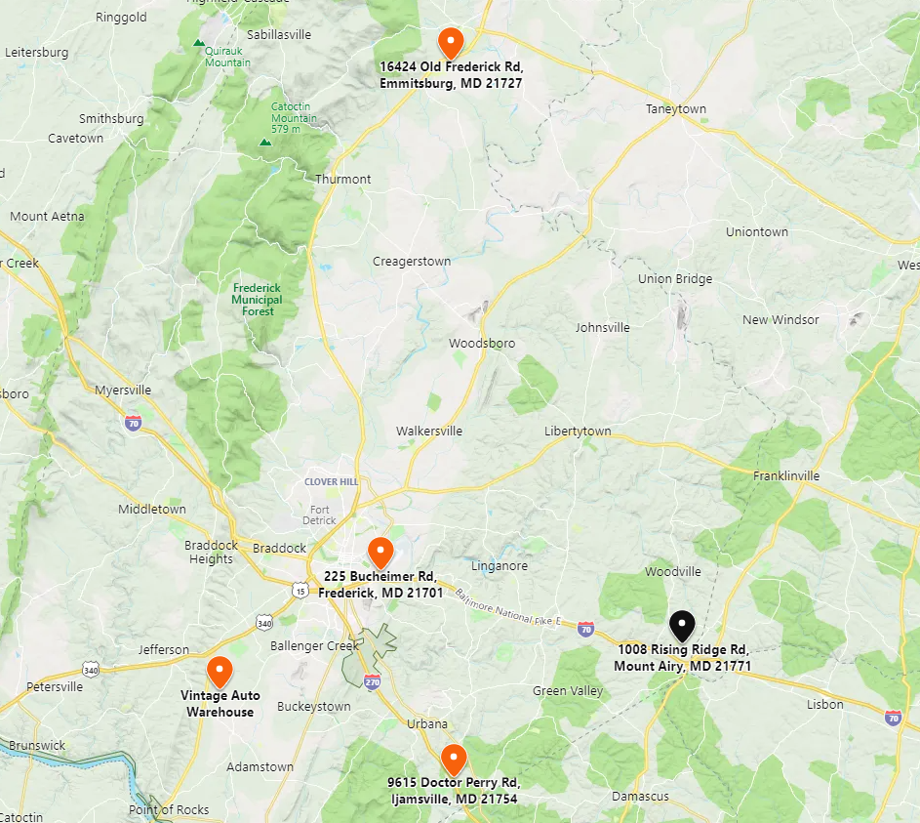

**RECONCILIATION OF VALUE INDICATIONS**

|  |  |
| --- | --- |
| Market Value as September 10, 2024 | Site Valuation Abandoned  Cost Approach Abandoned  Sales Comparison Approach $1,730,000  Income Capitalization Approach $1,765,000  **Conclusion:**  **$1,750,000** |

The use of the Cost Approach is more useful in the appraisal of special-purpose properties where no market data or income data is available. This approach was abandoned due to the age of the buildings, making the estimation of depreciation difficult.

The Sales Comparison Approach utilizes sales of similar properties for improved properties which reflect, including analysis of sales not included in this report, general market norms for condition and functional utility for both property types reflected in this report. The Sales Comparison Approach provides a cross section of data for analysis, as the comparable sales used in this report were sales that involved properties that would be best represent market norms for the sale of this property. Buildings are typically traded based on data gathered from sales of existing properties.

The Income Capitalization Approach is typically the best method for estimating value for properties where the owner is well verse in property management, market rents, and practices for a property type and subject area, or if they choose not to manage the property themselves, contract with a qualified real estate property management firm to do so.

The final opinion of value relied upon the sales comparison and income capitalization approaches. The opinion of value for the subject property is $1,750,000.

**ADDENDUM**

***MICHAEL PATRICK PUGH, MAI***

***APPRAISAL QUALIFICATIONS***

**LENGTH OF EXPERIENCE**

Fourteen years devoted to Real Estate Appraisal

19 Years Secondary Mortgage Market: Fannie Mae & Freddie Mac

**PROFESSIONAL ATTAINMENTS**

Designated Member of the Appraisal Institute (Member Number: 349530)

**Certified General Real Estate Appraiser**

**State of Maryland** (License No. 04-29481)

**EDUCATION**

Auburn University: Bachelor of Arts; International Relations/Political Science

Mount St. Mary's University: Masters of Business Administration – Honors Graduate

**APPRAISAL INSTITUTE EDUCATION**

|  |  |
| --- | --- |
| * Residential Valuation (1989) * Real Estate Appraisal Principals (2007) * Real Estate Appraisal Procedures (2007) * Uniform Standards of Professional Appraisal Practice (2007) * General Appraiser Market Analysis and Highest and Best Use (2007) * Real Estate Finance, Statistics, and Valuation Modeling (2007) * General Appraiser Income Approach/Part One (2007) * General Appraiser Income Approach/Part Two (2007) * Client Perspectives on Real Estate Appraisal (2007) * Condemnation Appraisal Principles (2007) * Business Practices and Ethics (2007) * General Appraiser Site Valuation and Cost Approach (2008) | * General Appraiser Sales Comparison Approach (2008) * General Appraiser Report Writing and Valuation Analysis (2009) * Advanced Sales Comparison and Cost Approach (2010) * Advanced Income Approach (2010) * Advanced Applications (2010) * MAI Comprehensive Examination (2012) * Supervisory Appraiser/Trainee Appraiser Course (2015) * Rates and Ratios: GIMs, OARs, and DCF (2016) * Analyzing Operating Expenses (2016) * Appraising Convenience Stores (2016) * Demonstration of Knowledge Report (2017) * 2016-2017 USPAP Update (2017) * 2018-2019 USPAP Update (2018) |

**APPRAISAL CLIENTS – SAMPLE**

|  |  |
| --- | --- |
| * ACNB Bank * Ameriserv Trust and Financial Services * BB&T Bank * Carroll Community Bank * Community Bank of the Chesapeake * Comstar Federal Credit Union * County First Bank * First United Bank and Trust * Frederick County Bank * Old Line Bank * Middletown Valley Bank * Woodsboro Bank * Revere Bank * Sandy Spring Bank * SonaBank | * City of Frederick * City of Takoma Park * Garrett County Government * Frederick County Government * Maryland National Capital Park and Planning * Montgomery County Housing Authority * Ralph J. Duffie, Inc. * Town of Mt. Airy * Town of Emmitsburg * Way Station, Inc. * WLR Investment Group, Inc. * YMCA of Frederick County * Other Clients: Attorneys (estate settlement/planning, litigation, divorce, real estate tax appeal), Real Estate Investors, Corporations. |

**SCOPE OF EXPERIENCE**

Apartment, Churches, Special Purpose, Mixed-Use, Retail, Office Buildings, Office Condominiums, Single-Family Residences, Vacant Land (residential, agricultural, commercial, industrial), Warehouse/Flex, Industrial, Manufacturing, and Farms.

**PURPOSE OF MOST APPRAISALS**

Acquisition/disposition, mortgage lending, estate planning and settlement, litigation, condemnation, easement valuation.

**JURISDICTIONS**

Maryland Counties: Allegany, Anne Arundel, Baltimore, Baltimore City, Charles, Calvert, Carroll, Frederick, Garrett, Howard, Montgomery, Prince George’s, St. Mary’s, Washington.

1. Source: The Dictionary of Real Estate Appraisal, Appraisal Institute, Sixth Edition, 2015
2. Source: FIRREA
3. Maryland Department of Labor, 2020 statistics.
4. U.S. Census Quickfacts, January 2024.
5. The Appraisal of Real Estate; 14th Edition; 2015
6. [1] Federal Reserve Bank of Richmond: Maryland Economic Snapshot, July 2024
7. Appraisal Institute. The Dictionary of Real Estate Appraisal. Sixth Edition; 2015